

Requirement & Design Specification
MEDBOOKING - PLATFORM TO SUPPORT ONLINE MEDICAL APPOINTMENT BOOKING
Version: 3.0

– Danang, July 2026–

Record of Changes
Version | Date | A*  M, D | In charge | Change Description
V1.0 | 1/10/2024 | A | All | Intial
V3.0 | 08/11/2024 | M | DngND | Modify all document
V3.0 | 05/11/2024 | A | DucNV | Add function Create new shipment Order
*A - Added M - Modified D - Deleted

Contents
Record of Changes 2
Record of Changes 2
Contents 3
Contents 3
I. Overview 10
I. Overview 10
1. User Requirements 10
1. User Requirements 10
1.1 Actors 10
1.1 Actors 10
1.2 Use Cases 11
1.2 Use Cases 11
a. Diagram(s) 11
b. Descriptions 18
2.2 Screen Descriptions 22
2.2 Screen Descriptions 22
2.3 Screen Authorization 26
2.3 Screen Authorization 26
2.4 Non-UI Functions 31
2.4 Non-UI Functions 31
3. System High Level Design 32
3. System High Level Design 32
3.1 Database Design 32
3.1 Database Design 32
a. Database Schema 32
b. Table Descriptions 32
3.2 Code Packages 35
3.2 Code Packages 35
1. Authentication 37
1. Authentication 37
1.1 UC-01_Register_Account 37
1.1 UC-01_Register_Account 37
a. Functionalities 37
b.Business Rule 39
1.2 UC-02_Complete_Onboarding_Survey 39
1.2 UC-02_Complete_Onboarding_Survey 39
a. Functionalities 39
b.Business Rule 40
1.3 UC-03_Login 40
1.3 UC-03_Login 40
a. Functionalities 40
b.Business Rule 41
1.4 UC-04_Reset_Pasword 41
1.4 UC-04_Reset_Pasword 41
a. Functionalities 41
b.Business Rule 42
1.5 UC-05_View_And_Update_Profile 43
1.5 UC-05_View_And_Update_Profile 43
a. Functionalities 43
b.Business Rule 44
2. Manage Admin's job posting 44
2. Manage Admin's job posting 44
2.1 UC-06_Search_Doctor 44
2.1 UC-06_Search_Doctor 44
a. Functionalities 44
b. Business Rules 45
2.2 UC-07_Filter_Doctor_bySpecialty 45
2.2 UC-07_Filter_Doctor_bySpecialty 45
a. Functionalities 45
b. Business Rules 45
2.3 UC-08_View_Doctor_Profile_and_Schedule 46
2.3 UC-08_View_Doctor_Profile_and_Schedule 46
a. Functionalities 46
b. Business Rules 46
2.4 UC-09_Search_Department 47
2.4 UC-09_Search_Department 47
a. Functionalities 47
b. Business Rules 47
2.5 UC-10_Book_Apponitment 47
2.5 UC-10_Book_Apponitment 47
a. Functionalities 47
b. Business Rules 48
2.6 UC-11_Select_Package_and_Time_Slot 49
2.6 UC-11_Select_Package_and_Time_Slot 49
a. Functionalities 49
b. Business Rules 50
2.7 UC-12_Pay_Deposit 50
2.7 UC-12_Pay_Deposit 50
a. Functionalities 50
b. Business Rules 51
2.8 UC-13_View_Upcoming_Appointments 51
2.8 UC-13_View_Upcoming_Appointments 51
a. Functionalities 51
b. Business Rules 52
2.9 UC-14_Cancel_Appointment 52
2.9 UC-14_Cancel_Appointment 52
a. Functionalities 52
b. Business Rules 53
2.10 UC-15_Reschedule_Appointment 53
2.10 UC-15_Reschedule_Appointment 53
a. Functionalities 53
b. Business Rules 54
2.11 UC-16_View_Payment_History 54
2.11 UC-16_View_Payment_History 54
a. Functionalities 54
b. Business Rules 55
3. Manage Admin's job posting 55
3. Manage Admin's job posting 55
3.1 UC-25_View_Work_Schedule_&_Location 55
3.1 UC-25_View_Work_Schedule_&_Location 55
a. Functionalities 55
b. Business Rules 56
3.2 UC-26_Add_Time_Slot 56
3.2 UC-26_Add_Time_Slot 56
a. Functionalities 56
b. Business Rules 57
3.3 UC-27_Edit_Time_Slot 57
3.3 UC-27_Edit_Time_Slot 57
a. Functionalities 57
b. Business Rules 57
3.4 UC-28_Delete_Time_Slot 58
3.4 UC-28_Delete_Time_Slot 58
a. Functionalities 58
b. Business Rules 58
3.5 UC-29_View_Patient_List 58
3.5 UC-29_View_Patient_List 58
a. Functionalities 58
b. Business Rules 59
3.6 UC-30_Confirm_Appointment 59
3.6 UC-30_Confirm_Appointment 59
a. Functionalities 59
b. Business Rules 60
3.7 UC-31_Decline_Appointment 60
3.7 UC-31_Decline_Appointment 60
a. Functionalities 60
b. Business Rules 61
3.8 UC-32_State_Decline_Reason 61
3.8 UC-32_State_Decline_Reason 61
a. Functionalities 61
b. Business Rules 62
4.Consultation 63
4.Consultation 63
4.1 UC-17_Join_Video_Call 63
4.1 UC-17_Join_Video_Call 63
a. Functionalities 63
b. Business Rules 63
4.2 UC-18_Chat_with_Doctor 64
4.2 UC-18_Chat_with_Doctor 64
a. Functionalities 64
b. Business Rules 64
4.3 UC-37_Conduct_Vide 65
4.3 UC-37_Conduct_Vide 65
a. Functionalities 65
b. Business Rules 65
4.4 UC-38_Chat_with_Patient 66
4.4 UC-38_Chat_with_Patient 66
a. Functionalities 66
b. Business Rules 66
5.Apply for a job 67
5.Apply for a job 67
5.1 UC-19_View_Diagnosis_ad_Health_Book 67
5.1 UC-19_View_Diagnosis_ad_Health_Book 67
a. Functionalities 67
b. Business Rules 67
5.2 UC-20_Download_Prescription 68
5.2 UC-20_Download_Prescription 68
a. Functionalities 68
b. Business Rules 68
5.3 UC-21_Rate_Dotor 68
5.3 UC-21_Rate_Dotor 68
a. Functionalities 68
b. Business Rules 69
5.4 UC-22_Write_Text_Review 69
5.4 UC-22_Write_Text_Review 69
a. Functionalities 69
b. Business Rules 70
5.5 UC-23_Submit_Complaint 70
5.5 UC-23_Submit_Complaint 70
a. Functionalities 70
b. Business Rules 71
5.6 UC-33_View_Patient_Record 71
5.6 UC-33_View_Patient_Record 71
a. Functionalities 71
b. Business Rules 72
5.7 UC-34_Fill_Examination_Form 72
5.7 UC-34_Fill_Examination_Form 72
a. Functionalities 72
b. Business Rules 73
5.8 UC-35_OrderLab_Test 73
5.8 UC-35_OrderLab_Test 73
a. Functionalities 73
b. Business Rules 74
5.9 UC-36_Write_Diagnosis_and_Issue_Prescription 74
5.9 UC-36_Write_Diagnosis_and_Issue_Prescription 74
a. Functionalities 74
b. Business Rules 75
6. Recruitment for job 75
6. Recruitment for job 75
6.1 UC-39_Review_and_Approve_Doctor 75
6.1 UC-39_Review_and_Approve_Doctor 75
a. Functional Description 75
b. Business Rules: 76
6.2 UC-40_Reject_Doctor 76
6.2 UC-40_Reject_Doctor 76
a. Functional Description 76
b. Business Rules 77
6.3 UC-41_Lock_Account 77
6.3 UC-41_Lock_Account 77
a. Functional Description 77
b. Business Rules 78
6.4 UC-42-Add_Department 78
6.4 UC-42-Add_Department 78
a. Functional Description 78
b. Business Rules 79
6.5 UC-43_Edit-Department 79
6.5 UC-43_Edit-Department 79
a. Functional Description 79
b. Business Rules 80
6.6 UC-44_Assign_Doctor_to_Departmet 80
6.6 UC-44_Assign_Doctor_to_Departmet 80
a. Functional Description 80
b. Business Rules 81
6.7 UC-45_View_Doctors_by_Department 81
6.7 UC-45_View_Doctors_by_Department 81
a. Functional Description 81
b. Business Rules 82
6.8 UC-46_Add_Specialty 82
6.8 UC-46_Add_Specialty 82
a. Functional Description 82
b. Business Rules 83
6.9 UC-47_Edit_Specialty 83
6.9 UC-47_Edit_Specialty 83
a. Functional Description 83
b. Business Rules 84
6.10 UC-48_Add_Examination_Package 84
6.10 UC-48_Add_Examination_Package 84
a. Functional Description 84
b. Business Rules 84
6.11 UC-49_Edit_Examination_Package 85
6.11 UC-49_Edit_Examination_Package 85
a. Functional Description 85
b. Business Rules 85
6.12 UC-50_View_Paymet_Statitics 86
6.12 UC-50_View_Paymet_Statitics 86
a. Functional Description 86
b. Business Rules 86
7. Work online through JobTrans 87
7. Work online through JobTrans 87
7.1 UC-51_View_Booking_Statistics 87
7.1 UC-51_View_Booking_Statistics 87
a. Functionalities 87
b. Business Rules 87
7.2. UC-52_Export_Statistics_Report 88
7.2. UC-52_Export_Statistics_Report 88
a. Functionalities 88
b. Business Rules 88
7.3. UC-53_View_Cancellation_Statistics 88
7.3. UC-53_View_Cancellation_Statistics 88
a. Functionalities 88
b. Business Rules 89
7.4.UC-54_Handle_Complaint 89
7.4.UC-54_Handle_Complaint 89
a. Functionalities 89
b. Business Rules 90
7.5. UC-55_Post_Epidemic_Alert 90
7.5. UC-55_Post_Epidemic_Alert 90
a. Functionalities 90
b. Business Rules 91
III. Design Specifications 91
III. Design Specifications 91
1. Business Rules 91
1. Business Rules 91
2. Application Messages List 94
2. Application Messages List 94

I. Overview

1. User Requirements

1.1 Actors
# | Actor | Description
1 | Admin | The highest priority manager, has authority to view details, create new, search, update and delete the post, user, transaction  - Has authority to manage users, transaction, recruitment post  - Has authority to manage profile
2 | Employer | Employers are businesses or individuals who have recruitment needs, using the Platform to post recruitment ads and search for suitable Seekers.
3 | Seeker | A Seeker is a job seeker who uses the Platform to find jobs, apply, and track the hiring process.
4 | Guest | A guest is a user visit website without loging in

1.2 Use Cases

a. Diagram(s)
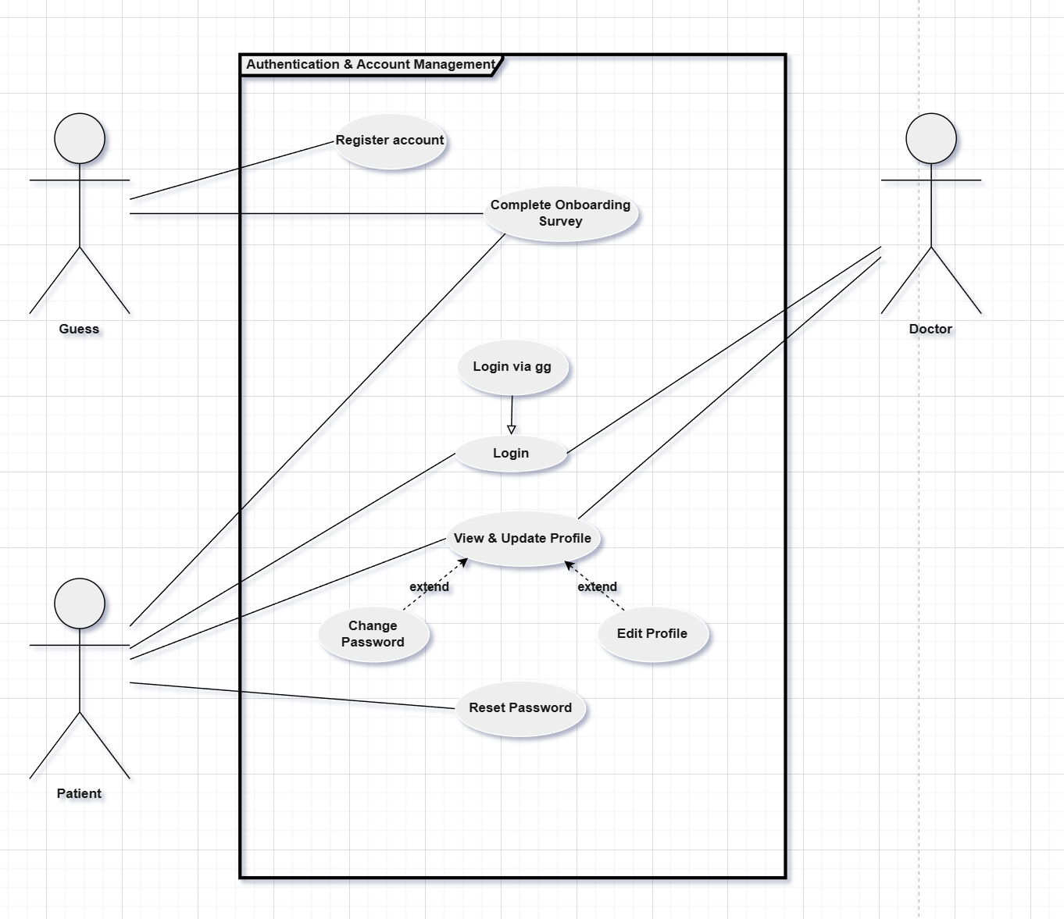
Figure 1. Authentication use case diagram
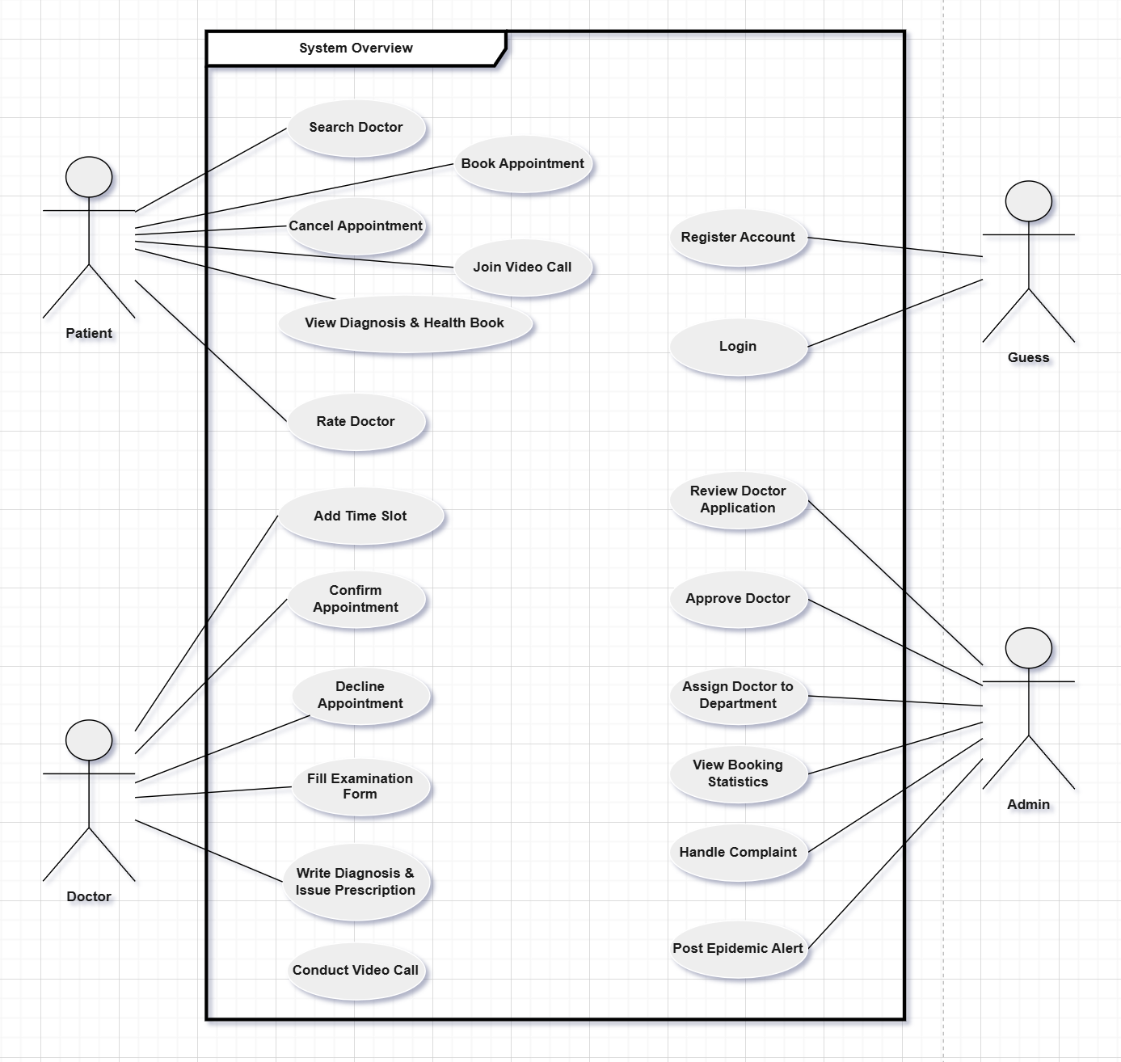
Figure 2. Overview use case diagram
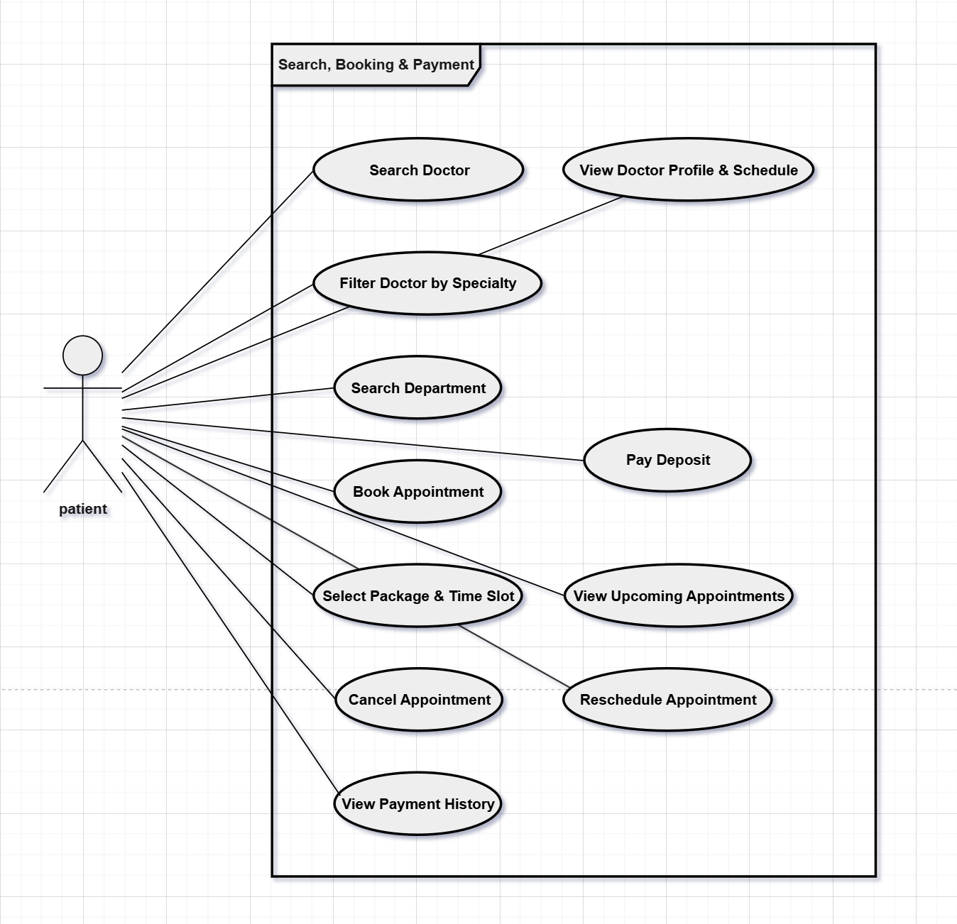Figure 3. Search,Booking & Payment use case diagram
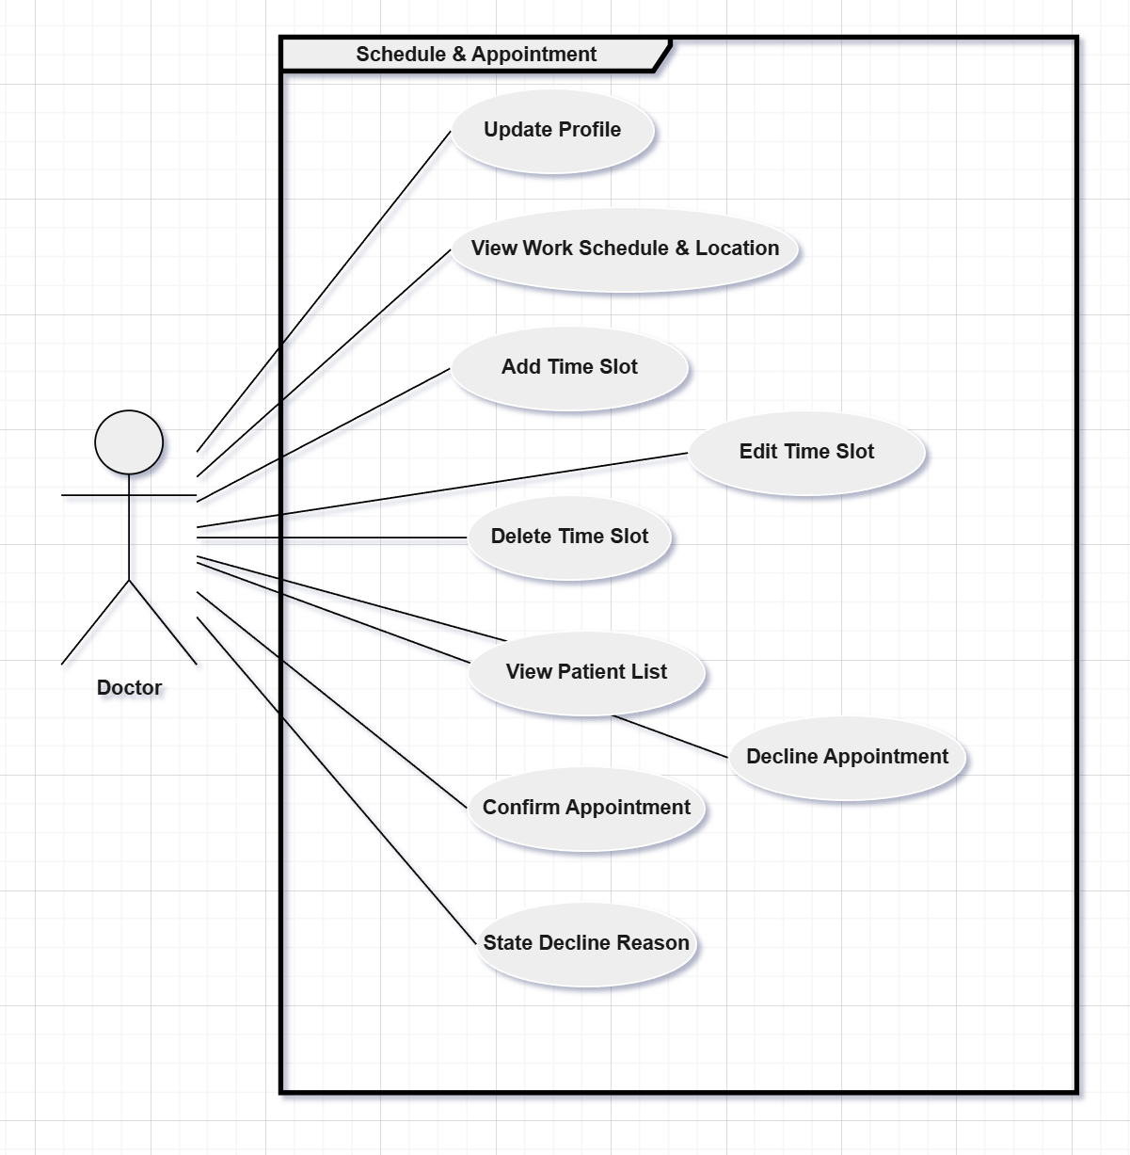
Figure 4. Doctor Schedule & Appointment use case diagram
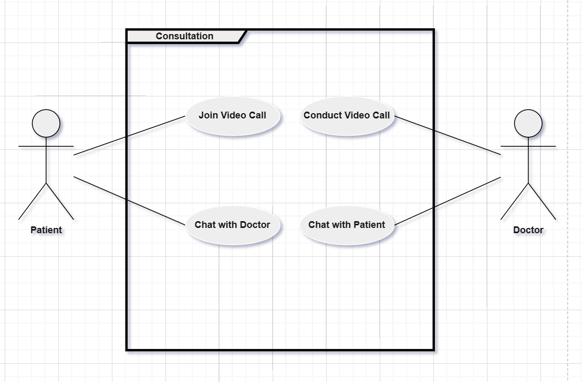
Figure 5. Consultation use case diagram
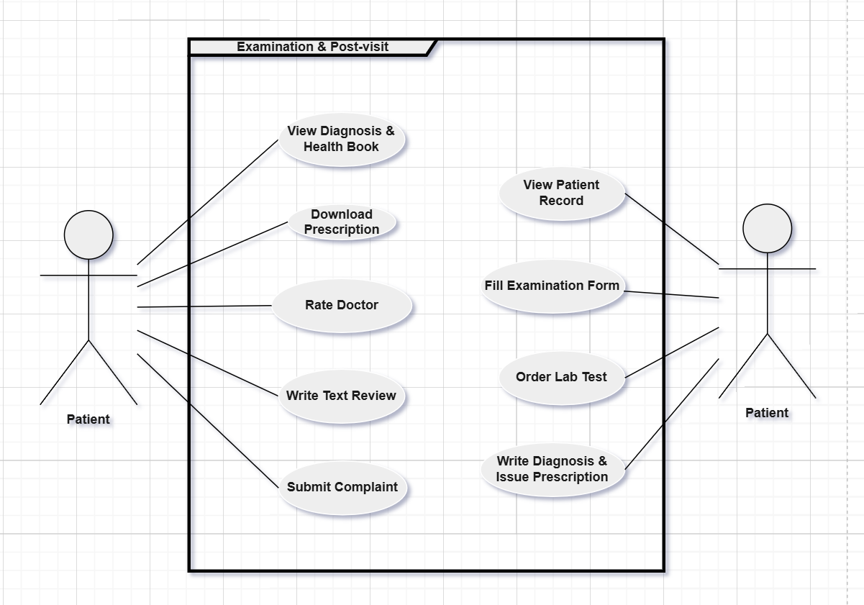
Figure 6. Examination & Post-visit use case diagram
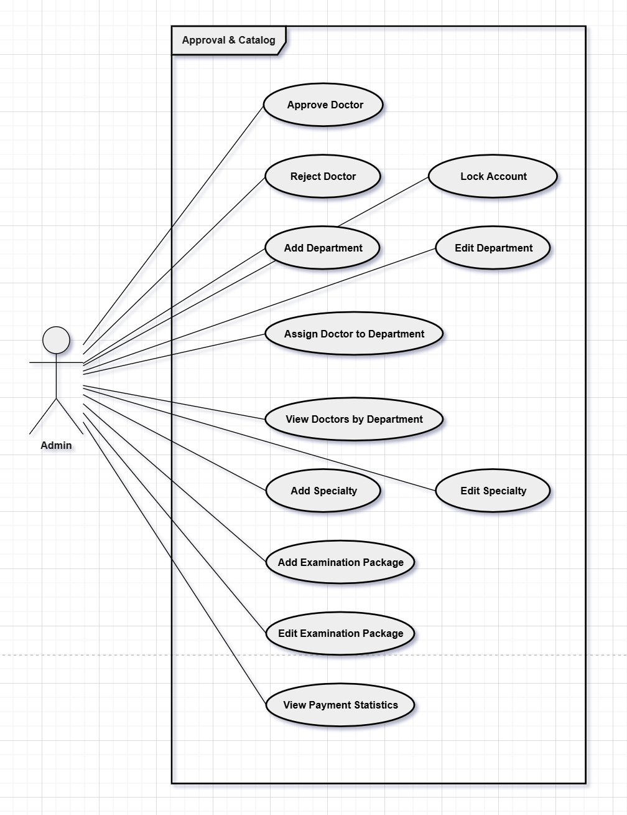
Figure 7. Admin:Approval & Catalog use case diagram
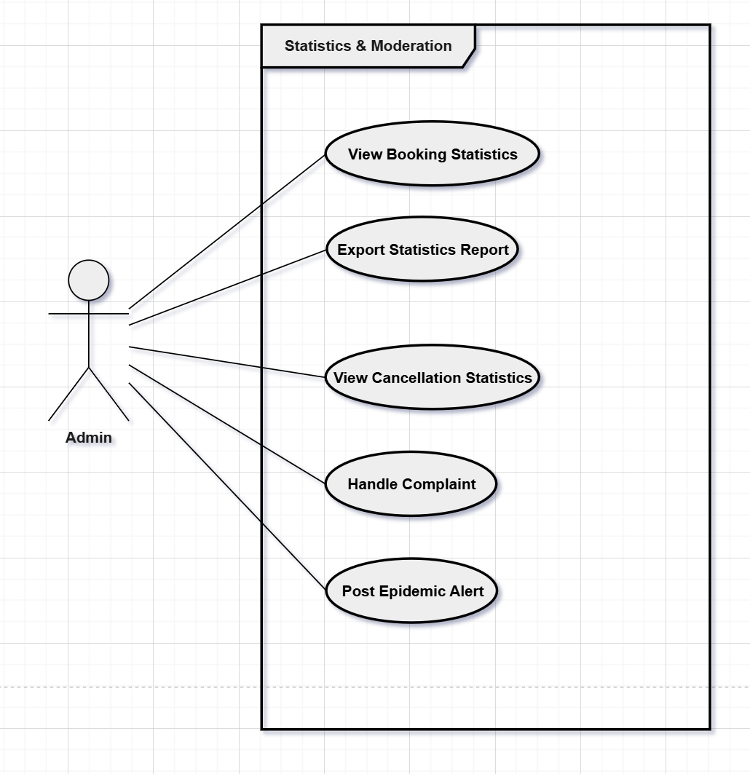
Figure 8. Admin:Statistics & Moderation use case diagram

b. Descriptions

ID | Feature | Use Case | Description
UC-01 | Authentication — Patient | Register Account | Register a new account using email and verify via OTP to access the hospital system.
UC-02 | Authentication — Patient | Complete Onboarding Survey | Fill in personal health info: gender, date of birth, medical history, and drug allergies after registration.
UC-03 | Authentication — Patient | Login | Access the system using email/password or Google OAuth.
UC-04 | Authentication — Patient | Reset Password | Request a password reset link sent to registered email.
UC-05 | Authentication — Patient | View & Update Profile | View and edit personal information and profile avatar.
UC-06 | Search & Discovery — Patient | Search Doctor | Search for doctors by name or specialty.
UC-07 | Search & Discovery — Patient | Filter Doctor by Specialty | Filter search results by medical specialty.
UC-08 | Search & Discovery — Patient | View Doctor Profile & Schedule | View doctor profile: fee, ratings, department, and available time slots.
UC-09 | Search & Discovery — Patient | Search Department | Search for hospital departments by name or specialty.
UC-10 | Booking — Patient | Book Appointment | Select an examination package and time slot, confirm booking, and pay deposit.
UC-11 | Booking — Patient | Select Package & Time Slot | Choose an examination package and an available time slot.
UC-12 | Booking — Patient | Pay Deposit | Pay the required deposit via payment gateway to confirm booking.
UC-13 | Booking — Patient | View Upcoming Appointments | View list of upcoming appointments and their current status.
UC-14 | Booking — Patient | Cancel Appointment | Cancel a booked appointment; refund deposit according to cancellation policy.
UC-15 | Booking — Patient | Reschedule Appointment | Reschedule an appointment to a different available time slot.
UC-16 | Booking — Patient | View Payment History | View transaction history and refund status.
UC-17 | Consultation — Patient | Join Video Call | Join a video consultation session with the doctor.
UC-18 | Consultation — Patient | Chat with Doctor | Send and receive real-time messages with the doctor.
UC-19 | Post-visit — Patient | View Diagnosis & Health Book | View diagnosis results, lab test results, and full medical record history.
UC-20 | Post-visit — Patient | Download Prescription | Download the prescription as a PDF file.
UC-21 | Post-visit — Patient | Rate Doctor | Submit a star rating and review after a completed appointment.
UC-22 | Post-visit — Patient | Write Text Review | Write a detailed text review alongside the star rating.
UC-23 | Post-visit — Patient | Submit Complaint | Submit a complaint about the doctor or service to Admin.
UC-24 | Profile & Schedule — Doctor | Update Profile | Update qualifications, experience, specialty, and profile photo.
UC-25 | Profile & Schedule — Doctor | View Work Schedule & Location | View weekly/monthly schedule overview and assigned department.
UC-26 | Profile & Schedule — Doctor | Add Time Slot | Create a new available appointment time slot.
UC-27 | Profile & Schedule — Doctor | Edit Time Slot | Edit information of an existing time slot.
UC-28 | Profile & Schedule — Doctor | Delete Time Slot | Remove a time slot that is no longer available.
UC-29 | Appointment — Doctor | View Patient List | View the list of patients who have booked appointments.
UC-30 | Appointment — Doctor | Confirm Appointment | Confirm an appointment booking request from a patient.
UC-31 | Appointment — Doctor | Decline Appointment | Decline an appointment booking; must provide a reason.
UC-32 | Appointment — Doctor | State Decline Reason | Enter and send the reason for declining the appointment to the patient.
UC-33 | Examination — Doctor | View Patient Record | View the patient's medical history and health profile.
UC-34 | Examination — Doctor | Fill Examination Form | Record vital signs, symptoms, and clinical notes. Required before issuing diagnosis.
UC-35 | Examination — Doctor | Order Lab Test | Request lab tests for the patient during examination.
UC-36 | Examination — Doctor | Write Diagnosis & Issue Prescription | Write the diagnosis and prescribe medicines after completing the examination form.
UC-37 | Consultation — Doctor | Conduct Video Call | Initiate or join a video consultation session with a patient.
UC-38 | Consultation — Doctor | Chat with Patient | Send and receive real-time messages with the patient.
UC-39 | Doctor Approval — Admin | Review & Approve Doctor | Review doctor registration profile and approve or reject the request.
UC-40 | Doctor Approval — Admin | Reject Doctor | Reject a doctor registration and record the reason shown to the doctor.
UC-41 | Doctor Approval — Admin | Lock Account | Lock a doctor or patient account that violates system policies.
UC-42 | Department — Admin | Add Department | Add a new hospital department to the system.
UC-43 | Department — Admin | Edit Department | Edit information of an existing hospital department.
UC-44 | Department — Admin | Assign Doctor to Department | Assign a doctor to a specific department.
UC-45 | Department — Admin | View Doctors by Department | View the list of doctors belonging to each department.
UC-46 | Specialty Catalog — Admin | Add Specialty | Add a new medical specialty to the catalog.
UC-47 | Specialty Catalog — Admin | Edit Specialty | Edit information of an existing medical specialty.
UC-48 | Examination Package — Admin | Add Examination Package | Create a new examination package: name, price, and included services.
UC-49 | Examination Package — Admin | Edit Examination Package | Edit information of an existing examination package.
UC-50 | Examination Package — Admin | View Payment Statistics | View statistics on revenue, deposit payments, and refunds.
UC-51 | Statistics — Admin | View Booking Statistics | View booking statistics by time period, specialty, and department.
UC-52 | Statistics — Admin | Export Statistics Report | Export statistics report to a file.
UC-53 | Statistics — Admin | View Cancellation Statistics | View appointment cancellation and reschedule rates.
UC-54 | Moderation — Admin | Handle Complaint | Receive, review, and respond to patient complaints.
UC-55 | Moderation — Admin | Post Epidemic Alert | Post epidemic alerts and send notifications to patients.

2.2 Screen Descriptions

ID | Feature | Screen | Description
1 | View hospital introduction and CTA | Landing Page | Allows all users to view hospital introduction and CTA.
2 | Fill in registration information - Guest | Register | Allows guests to fill in registration information.
3 | Complete Onboarding Survey and verify OTP via email - Guest | Register | Allows guests to complete Onboarding Survey and verify OTP via email.
4 | Enter email/password and get redirected by role after login | Login | Allows all users to enter email and password and be redirected by role after login.
5 | Fill in email | Forgot Password | Allows all users to fill in email.
6 | Receive OTP code and set new password | Forgot Password | Allows all users to receive OTP code and enter it to set a new password.
7 | View upcoming appointments, recent medical records and notifications - Patient | Patient Dashboard | Allows patients to view upcoming appointments, recent medical records and notifications.
8 | Search and filter doctor by name or specialty | Search & Discovery | Allows guests and patients to search and filter doctor by name or specialty.
9 | View doctor profile and schedule | Search & Discovery | Allows guests and patients to view doctor profile and schedule.
10 | Search hospital department | Search & Discovery | Allows guests and patients to search hospital department.
11 | Select examination package and available time slot - Patient | Book Appointment | Allows patients to select examination package and available time slot.
12 | Pay Deposit and view booking confirmation - Patient | Book Appointment | Allows patients to pay deposit and view booking confirmation.
13 | View upcoming and past appointments - Patient | Appointment List | Allows patients to view upcoming and past appointments.
14 | Reschedule or cancel appointment - Patient | Appointment List | Allows patients to reschedule or cancel appointment.
15 | View transaction list and refund status - Patient | Payment History | Allows patients to view transaction list and refund status.
16 | View appointment information - Patient | Appointment Detail | Allows patients to view appointment information.
17 | Send message and join video call with doctor - Patient | Appointment Detail | Allows patients to send message to doctor and join video call with doctor.
18 | Submit appointment rating and complaint - Patient | Appointment Detail | Allows patients to submit appointment rating and submit complaint.
19 | View all medical records and record detail (diagnosis, meds) - Patient | Health Book | Allows patients to view all medical records and view record detail (diagnosis, meds).
20 | View lab test results - Patient | Health Book | Allows patients to view lab test results.
21 | Download prescription PDF - Patient | Health Book | Allows patients to download prescription PDF.
22 | View and edit profile information (name, avatar, phone) | Profile | Allows logged-in users to view profile information and edit name, avatar, phone.
23 | Fill in old/new password and confirm password change | Change Password | Allows logged-in users to fill in old and new password and confirm password change.
24 | Toggle email and push notification | Notification Settings | Allows patients and doctors to toggle email notification and push notification.
25 | View today's appointment schedule and pending appointments - Doctor | Doctor Dashboard | Allows doctors to view today's appointment schedule and pending appointments.
26 | View weekly/monthly schedule overview and assigned department - Doctor | View Work Schedule & Location | Allows doctors to view weekly/monthly schedule overview and assigned department.
27 | Add, edit and delete time slot - Doctor | Doctor Schedule Management | Allows doctors to add, edit and delete time slot.
28 | View all assigned appointments - Doctor | Appointment Management (Doctor) | Allows doctors to view all assigned appointments.
29 | Confirm or decline appointment with reason - Doctor | Appointment Management (Doctor) | Allows doctors to confirm appointment or decline appointment with reason.
30 | View patient medical record and record vitals/symptoms - Doctor | Examination | Allows doctors to view patient medical record and record patient vitals and symptoms.
31 | Request and update lab test results - Doctor | Examination | Allows doctors to request lab tests and update lab test results.
32 | Write diagnosis, prescribe medicines and issue prescription PDF - Doctor | Medical Record | Allows doctors to write diagnosis and prescribe medicines, and issue prescription (PDF generated).
33 | Send message and view message history - Doctor | Messaging (Doctor) | Allows doctors to send message to patient and view message history per appointment.
34 | Initiate video call with patient - Doctor | Video Call (Doctor) | Allows doctors to initiate video call with patient.
35 | View system overview statistics, recent complaints and alerts - Admin | Admin Dashboard | Allows admins to view system overview statistics and recent complaints and alerts.
36 | View, search and filter users by role - Admin | User Management | Allows admins to view all users list, search and filter users by role.
37 | Ban/unban or delete user account - Admin | User Management | Allows admins to ban or unban user account, or delete user account.
38 | View pending doctor registrations - Admin | Doctor Approval | Allows admins to view pending doctor registrations.
39 | Approve or reject doctor registration with reason - Admin | Doctor Approval | Allows admins to approve doctor registration or reject with reason.
40 | Add and edit department - Admin | Department & Specialty Management | Allows admins to add and edit department.
41 | Assign doctor to department - Admin | Department & Specialty Management | Allows admins to assign doctor to department.
42 | View doctors by department - Admin | Department & Specialty Management | Allows admins to view doctors by department.
43 | Add and edit specialty - Admin | Department & Specialty Management | Allows admins to add and edit specialty.
44 | Add and edit examination package - Admin | Examination Package Management | Allows admins to add and edit examination package.
45 | View revenue/deposit statistics and refund history - Admin | Payment Statistics | Allows admins to view revenue and deposit statistics and refund history.
46 | View all complaints - Admin | Complaint Management | Allows admins to view all complaints.
47 | Respond to and resolve complaint - Admin | Complaint Management | Allows admins to respond to and resolve complaint.
48 | View booking statistics by time/specialty - Admin | Booking & Cancellation Statistics | Allows admins to view booking statistics by time/specialty.
49 | Export statistics report - Admin | Booking & Cancellation Statistics | Allows admins to export statistics report.
50 | View cancellation statistics - Admin | Booking & Cancellation Statistics | Allows admins to view cancellation statistics.
51 | Post epidemic alert - Admin | Moderation | Allows admins to post epidemic alert.
52 | Send notification to all patients - Admin | Moderation | Allows admins to send notification to all patients.

2.3 Screen Authorization

Screen | Guest | Patient | Doctor | Admin
Landing Page | X | X | X | X
View hospital introduction and CTA | X | X | X | X
Register | X
Fill in registration information | X
Complete Onboarding Survey | X
Verify OTP via email | X
Login | X | X | X | X
Enter email and password | X | X | X | X
Redirect by role after login |  | X | X | X
Logout |  | X | X | X
Forgot Password | X | X | X | X
Fill in email | X | X | X | X
Receive OTP code | X | X | X | X
Enter OTP and set new password | X | X | X | X
Patient Dashboard |  | X
View upcoming appointments |  | X
View recent medical records |  | X
View notifications |  | X
Search & Discovery | X | X
Search doctor by name or specialty | X | X
Filter doctor by specialty | X | X
View doctor profile and schedule | X | X
Search hospital department | X | X
Book Appointment |  | X
Select examination package |  | X
Select available time slot |  | X
Pay Deposit |  | X
View booking confirmation |  | X
Appointment List |  | X
View upcoming and past appointments |  | X
Reschedule appointment |  | X
Cancel appointment |  | X
Payment History |  | X
View transaction list and refund status |  | X
Appointment Detail |  | X
View appointment information |  | X
Send message to doctor |  | X
Join video call with doctor |  | X
Submit appointment rating |  | X
Submit complaint |  | X
Health Book |  | X
View all medical records |  | X
View record detail (diagnosis, meds) |  | X
View lab test results |  | X
Download prescription PDF |  | X
Profile |  | X | X | X
View profile information |  | X | X | X
Edit name, avatar, phone |  | X | X | X
Change Password |  | X | X | X
Fill in old and new password |  | X | X | X
Confirm password change |  | X | X | X
Notification Settings |  | X | X
Toggle email notification |  | X | X
Toggle push notification |  | X | X
Doctor Dashboard |  |  | X
View today's appointment schedule |  |  | X
View pending appointments |  |  | X
View Work Schedule & Location |  |  | X
View weekly/monthly schedule overview |  |  | X
View assigned department |  |  | X
Doctor Schedule Management |  |  | X
Add time slot |  |  | X
Edit time slot |  |  | X
Delete time slot |  |  | X
Appointment Management (Doctor) |  |  | X
View all assigned appointments |  |  | X
Confirm appointment |  |  | X
Decline appointment with reason |  |  | X
Examination |  |  | X
View patient medical record |  |  | X
Record patient vitals and symptoms |  |  | X
Request lab tests |  |  | X
Update lab test results |  |  | X
Medical Record |  |  | X
Write diagnosis and prescribe medicines |  |  | X
Issue prescription (PDF generated) |  |  | X
Messaging (Doctor) |  |  | X
Send message to patient |  |  | X
View message history per appointment |  |  | X
Video Call (Doctor) |  |  | X
Initiate video call with patient |  |  | X
Admin Dashboard |  |  |  | X
View system overview statistics |  |  |  | X
View recent complaints and alerts |  |  |  | X
User Management |  |  |  | X
View all users list |  |  |  | X
Search and filter users by role |  |  |  | X
Ban or unban user account |  |  |  | X
Delete user account |  |  |  | X
Doctor Approval |  |  |  | X
View pending doctor registrations |  |  |  | X
Approve doctor registration |  |  |  | X
Reject doctor with reason |  |  |  | X
Department & Specialty Management |  |  |  | X
Add department |  |  |  | X
Edit department |  |  |  | X
Assign doctor to department |  |  |  | X
View doctors by department |  |  |  | X
Add specialty |  |  |  | X
Edit specialty |  |  |  | X
Examination Package Management |  |  |  | X
Add examination package |  |  |  | X
Edit examination package |  |  |  | X
Payment Statistics |  |  |  | X
View revenue and deposit statistics |  |  |  | X
View refund history |  |  |  | X
Complaint Management |  |  |  | X
View all complaints |  |  |  | X
Respond to and resolve complaint |  |  |  | X
Booking & Cancellation Statistics |  |  |  | X
View booking statistics by time/specialty |  |  |  | X
Export statistics report |  |  |  | X
View cancellation statistics |  |  |  | X
Moderation |  |  |  | X
Post epidemic alert |  |  |  | X
Send notification to all patients |  |  |  | X

2.4 Non-UI Functions

ID | Feature | System Function | Description
1 | <<Feature Name>> | <<Function Name1>> | <<Function Name1 Description>>
2 | …

3. System High Level Design

3.1 Database Design

a. Database Schema
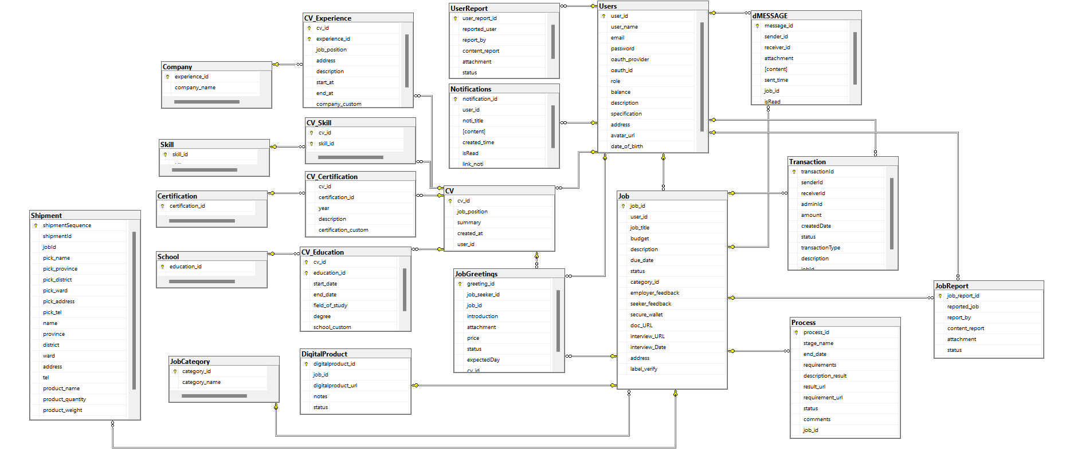

b. Table Descriptions
No | Table Name | Description
1 | Roles | Danh sách vai trò trong hệ thống (ví dụ: admin, doctor, patient). Được tham chiếu bởi bảng Users để phân quyền người dùng.
2 | Users | Tài khoản đăng nhập cho mọi role (ADMIN / DOCTOR / PATIENT). Lưu thông tin cá nhân, trạng thái hoạt động, và cài đặt thông báo (email_notify, push_notify). Tích hợp Notification_Settings.
3 | Password_Resets | Quản lý token đặt lại mật khẩu. Mỗi token có thời hạn hết hạn (expires_at) và trạng thái xử lý (pending/used). Liên kết với Users qua user_id.
4 | Patients | Thông tin y tế của bệnh nhân: nhóm máu, tiền sử bệnh, bệnh hiện tại, dị ứng. Mỗi bệnh nhân tương ứng 1 tài khoản Users (1-1).
5 | Health_Books | Sổ sức khỏe điện tử của bệnh nhân. Mỗi bệnh nhân có đúng 1 sổ (1-1 với Patients). Làm đầu mối tập hợp toàn bộ hồ sơ bệnh án (Medical_Records).
6 | Specialties | Danh mục chuyên khoa y tế (Tim mạch, Nhi khoa, Da liễu...). Được tham chiếu bởi Doctors để xác định chuyên môn bác sĩ.
7 | Departments | Các khoa/phòng ban trong bệnh viện. Mỗi khoa có vị trí (location) và trạng thái hoạt động. Liên kết với Doctors.
8 | Doctors | Thông tin chuyên môn của bác sĩ: chuyên khoa, khoa phòng, kinh nghiệm, phí khám, chức vụ. Trạng thái mặc định là 'pending' cho đến khi được Admin duyệt.
9 | Doctor_Approvals | Lưu lịch sử phê duyệt/từ chối tài khoản bác sĩ. Admin xét duyệt kèm lý do từ chối nếu có. Theo dõi thời điểm xem xét (reviewed_at).
10 | Doctor_Schedules | Lịch làm việc của bác sĩ theo từng ngày: ngày làm, giờ bắt đầu/kết thúc, trạng thái còn chỗ (is_available). Dùng để bệnh nhân đặt lịch hẹn.
11 | Appointments | Lịch hẹn khám giữa bệnh nhân và bác sĩ. Liên kết với lịch làm việc (Doctor_Schedules). Ghi nhận loại khám, thời điểm đặt, trạng thái và lý do hủy.
12 | Examinations | Kết quả khám lâm sàng: nhiệt độ, huyết áp, nhịp tim, cân nặng, chiều cao, triệu chứng, ghi chú. Mỗi lịch hẹn có tối đa 1 phiếu khám (1-1 với Appointments).
13 | Lab_Tests | Các xét nghiệm được yêu cầu trong buổi khám. Lưu tên xét nghiệm, kết quả và trạng thái (pending/completed). Nhiều xét nghiệm có thể thuộc 1 lần khám.
14 | Medical_Records | Hồ sơ bệnh án sau mỗi lần khám: chẩn đoán và ghi chú của bác sĩ. Gắn với sổ sức khỏe (Health_Books) và lịch hẹn (Appointments). Tích hợp thông tin đơn thuốc qua Medicines.
15 | Medicines | Danh sách thuốc trong đơn kê của hồ sơ bệnh án: tên thuốc, liều dùng, phân loại, đơn vị. Thay thế bảng Prescriptions riêng lẻ, gắn trực tiếp vào Medical_Records.
16 | Messages | Tin nhắn trao đổi giữa bệnh nhân và bác sĩ trong khuôn khổ một lịch hẹn cụ thể. Ghi nhận người gửi, người nhận, nội dung và loại tin nhắn.
17 | Video_Calls | Cuộc gọi video giữa bệnh nhân và bác sĩ. Mỗi lịch hẹn có tối đa 1 cuộc gọi (1-1). Ghi nhận người khởi tạo, loại cuộc gọi, trạng thái và thời điểm bắt đầu.
18 | Appointment_Ratings | Đánh giá sau khám của bệnh nhân dành cho bác sĩ: điểm (1-5) và nhận xét. Mỗi lịch hẹn chỉ có 1 đánh giá (1-1 với Appointments).
19 | Complaints | Khiếu nại của bệnh nhân liên quan đến lịch hẹn: tiêu đề, mô tả, trạng thái xử lý và phản hồi của Admin. Hỗ trợ quy trình giải quyết khiếu nại nội bộ.
20 | Articles | Bài viết/tin tức y tế được đăng bởi người dùng trong hệ thống (Admin hoặc Doctor). Phân loại theo type và theo dõi thời gian tạo/cập nhật.

3.2 Code Packages
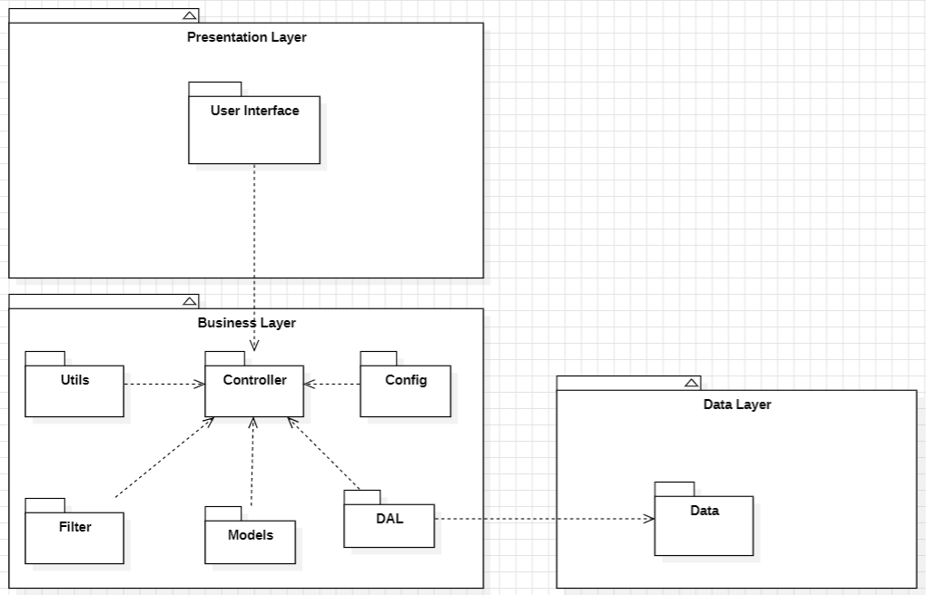
Package descriptions
No | Package | Description
1 | Presentation Layer | Contains the User Interface components, handling the user's interaction with the hospital system (booking, medical records, dashboards).
2 | Business Layer | Contains the core business logic and processing modules, managing data flow, appointment scheduling, and medical workflows.
3 | Data Layer | Manages the data access logic, handling storage and retrieval from the hospital database.
4 | Controller | Acts as a bridge between the User Interface and other modules in the Business Layer, routing HTTP requests to appropriate services.
5 | Utils | Provides utility functions and common services used across the application (date formatting, token generation, validators).
6 | Config | Manages configuration settings and application environment variables (database connection, JWT secret, mail server config).
7 | Filter / Middleware | Contains filters for data validation, authentication, authorization, and request processing (JWT verification, role checks).
8 | Models | Represents the data structure and entities used within the hospital domain (Users, Doctors, Patients, Appointments, etc.).
9 | DAL (Data Access Layer) | Handles database operations specifically for retrieving and saving data via ORM or raw SQL queries.
10 | Auth Service | Manages user authentication flows: login, registration, password reset via OTP, and session management.
11 | User Service | Handles CRUD operations for user accounts, profile management, and notification preference settings.
12 | Doctor Service | Manages doctor profiles, approval workflow by Admin, schedule creation, and specialty/department assignments.
13 | Appointment Service | Core service for booking, confirming, cancelling, and rescheduling appointments, and linking them to doctor schedules.
14 | Examination Service | Records clinical examination results (vitals, symptoms) and manages lab test requests per appointment.
15 | Medical Record Service | Creates and manages patient health records including diagnosis, doctor notes, and prescribed medicines per appointment.
16 | Messaging Service | Handles real-time or asynchronous messaging between doctors and patients within the context of an appointment.
17 | Video Call Service | Manages video call sessions initiated between doctor and patient for telemedicine consultations.
18 | Rating & Complaint Service | Handles post-visit appointment ratings submitted by patients and manages complaint submission and Admin review workflow.
19 | Payment Service | Manages deposit payment and refund flows when a patient books or cancels an appointment. Integrates with third-party payment gateway (e.g. VNPay/Momo). Tracks all transactions in Payment History.
20 | Email Notification Service | Sends automated emails to users for key events: appointment confirmation, appointment reminder (24h/1h before), lab result availability, prescription PDF, and deposit/refund receipts.
21 | Examination Package Service | Manages examination packages created by Admin: name, price, and included services. Provides package selection during the booking flow and links packages to appointments.
22 | Content Service | Manages creation and publishing of health-related articles and epidemic alerts by Admins for patient education and public health notification.

II. Requirement Specifications

1. Authentication

1.1 UC-01_Register_Account

a. Functionalities
UC ID and Name: | UC-01_Register_Account
Created By: | Hospital Dev Team | Date Created: | 01/Jun/2025
Primary Actor: | Guest | Secondary Actors: | None
Trigger: | Guest clicks the 'Register' button on the landing page.
Description: | As a Guest, I want to register a new account so that I can access the hospital booking and medical features.
Preconditions: | The email address must not already be registered in the system.
Postconditions: | A new Patient account is created, an OTP verification email is sent, and the Guest is redirected to the OTP verification screen.
Normal Flow: | 1.0 Register Account  1. Guest navigates to the platform and clicks the 'Register' button.  2. System displays a registration form requesting email, password, confirm password, and full name.  3. Guest fills in all required fields with valid information.  4. Guest clicks the 'Register' button to submit the form.  5. System validates the input (email format, password length ≥ 8, email uniqueness).  6. System creates a new user record with role PATIENT.  7. System sends a 6-digit OTP to the provided email (expires in 10 minutes).  8. System redirects the Guest to the OTP verification screen.  9. Guest enters the 6-digit OTP received by email.  10. System verifies the OTP and activates the account.  11. System redirects the user to the Onboarding screen (UC-02).
Alternative Flows: | None
Exceptions: | 1.0.E1 Invalid field format  1. System displays inline error MSG01 if email format is invalid.  2. System displays inline error MSG02 if password < 8 characters.  3. System displays inline error MSG11 if confirm password does not match.  1.0.E2 Email already registered  1. System displays toast error MSG03.  1.0.E3 OTP incorrect or expired  1. System displays toast error MSG09.  2. Guest can request a new OTP after 60 seconds.
Priority: | Must Have
Frequency of Use:
Business Rules: | BR-01, BR-02, BR-03, BR-08
Other Information:
Assumptions:

b.Business Rule
ID | Business Rule | Business Rule Description
BR-01 | Wrong email rule | Notify Guest with MSG01 if they do not provide a valid email address.
BR-02 | Wrong password rule | Notify User with MSG02 if password is less than 8 characters.
BR-03 | Used email rule | Notify Guest with MSG03 if the email has already been registered.
BR-08 | Wrong re-entered password rule | Notify User with MSG11 if confirm password does not match.

1.2 UC-02_Complete_Onboarding_Survey

a. Functionalities
UC ID and Name: | UC-02_Complete_Onboarding_Survey
Created By: | Hospital Dev Team | Date Created: | 01/Jun/2025
Primary Actor: | Patient (new) | Secondary Actors: | None
Trigger: | System automatically redirects the Patient to Onboarding after successful registration.
Description: | As a new Patient, I want to complete the onboarding survey so that my health profile is initialized.
Preconditions: | Patient has successfully registered and verified OTP (UC-01). Onboarding not yet completed.
Postconditions: | Patient health profile saved. Health Book created. Patient redirected to dashboard.
Normal Flow: | 2.0 Complete Onboarding Survey  1. System redirects Patient to the Onboarding screen after OTP verification.  2. System displays a multi-step form: gender, date of birth, blood type, medical history, drug allergies.  3. Patient fills in all required fields.  4. Patient clicks 'Complete' to submit the survey.  5. System saves the health profile to the Patients table.  6. System creates a Health Book record linked to the Patient.  7. System redirects the Patient to the main dashboard.
Alternative Flows: | None
Exceptions: | None
Priority: | Must Have
Frequency of Use:
Business Rules: | BR-27
Other Information:
Assumptions:

b.Business Rule
ID | Business Rule | Business Rule Description
BR-27 | Health Book creation rule | Each Patient account must have exactly one Health Book, created automatically upon profile creation.

1.3 UC-03_Login

a. Functionalities
UC ID and Name: | UC-03_Login
Created By: | Hospital Dev Team | Date Created: | 01/Jun/2025
Primary Actor: | Patient / Doctor / Admin | Secondary Actors: | None
Trigger: | User clicks the 'Login' button on the landing page or header.
Description: | As a User, I want to log in to the system so that I can access my personalized dashboard and authenticated features.
Preconditions: | User must have a registered and active account in the system.
Postconditions: | User is authenticated, JWT token issued, redirected to role-based homepage.
Normal Flow: | 3.0 Login  1. User navigates to the platform and clicks the 'Login' button.  2. System displays the login form requesting email and password.  3. User enters valid email and password credentials.  4. User clicks the 'Login' button.  5. System validates the credentials against the database.  6. System issues a JWT token and stores it in a secure cookie.  7. System redirects the User to the appropriate homepage based on role.
Alternative Flows: | 3.1 Google OAuth Login  1. User clicks 'Login with Google'.  2. System redirects to Google OAuth 2.0 consent screen.  3. User selects a Google account and grants permission.  4. Google redirects back with an authorization token.  5. System verifies the token and retrieves or creates the user account.  6. Return to step 6 of Normal Flow.
Exceptions: | 3.0.E1 Authentication failed  1. System displays toast error MSG04.  2. User may retry or click 'Forgot Password?' (→ UC-04).
Priority: | Must Have
Frequency of Use:
Business Rules: | BR-01, BR-02, BR-04
Other Information:
Assumptions:

b.Business Rule
ID | Business Rule | Business Rule Description
BR-01 | Wrong email rule | Notify User with MSG01 if email format is invalid.
BR-02 | Wrong password rule | Notify User with MSG02 if password is less than 8 characters.
BR-04 | Login notification rule | Notify with MSG04 if credentials are wrong; notify with MSG05 and redirect by role if correct.

1.4 UC-04_Reset_Pasword

a. Functionalities
UC ID and Name: | UC-04_Reset_Password
Created By: | Hospital Dev Team | Date Created: | 01/Jun/2025
Primary Actor: | Patient / Doctor / Admin | Secondary Actors: | None
Trigger: | User clicks the 'Forgot Password?' link on the login screen.
Description: | As a User, I want to reset my password via email OTP so that I can regain access to my account.
Preconditions: | User must have a registered email in the system.
Postconditions: | User's password is updated and the user can log in with the new password.
Normal Flow: | 4.0 Reset Password  1. User clicks 'Forgot Password?' on the login screen.  2. System displays an email input form.  3. User enters their registered email address.  4. System checks if the email exists in the database.  5. System sends a 6-digit OTP to the email (expires in 10 minutes).  6. System notifies User with MSG08 that OTP has been sent.  7. User enters the OTP on the verification screen.  8. System verifies the OTP.  9. System redirects User to the set new password form.  10. User enters and confirms the new password.  11. System updates the password and notifies User with MSG10.  12. System redirects User to the Login screen.
Alternative Flows: | None
Exceptions: | 4.0.E1 Email not registered  System displays toast MSG07.  4.0.E2 OTP incorrect  System displays toast MSG09. User can request new OTP after 60 seconds.  4.0.E3 Passwords do not match  System displays inline error MSG11.
Priority: | Must Have
Frequency of Use:
Business Rules: | BR-06, BR-07, BR-08
Other Information:
Assumptions:

b.Business Rule
ID | Business Rule | Business Rule Description
BR-06 | Email check rule | Notify with MSG07 if email not registered, or MSG08 if OTP sent successfully.
BR-07 | OTP validation rule | Notify with MSG09 if OTP incorrect; notify with MSG10 and redirect if correct.
BR-08 | Password match rule | Notify User with MSG11 if re-entered password does not match.

1.5 UC-05_View_And_Update_Profile

a. Functionalities
UC ID and Name: | UC-05_View_and_Update_Profile
Created By: | Hospital Dev Team | Date Created: | 01/Jun/2025
Primary Actor: | Patient / Doctor / Admin | Secondary Actors: | None
Trigger: | User navigates to the Profile page from the navigation menu.
Description: | As a User, I want to view and edit my personal information and avatar so that my profile is up to date.
Preconditions: | User must be logged in.
Postconditions: | Updated profile information is saved to the database.
Normal Flow: | 5.0 View & Update Profile  1. User clicks on their avatar or 'Profile' in the navigation menu.  2. System displays the profile page with current information.  3. User clicks 'Edit' to modify fields (name, phone, avatar, gender, date of birth).  4. User makes changes and clicks 'Save'.  5. System validates the input and saves the updated information.  6. System displays a success notification.
Alternative Flows: | None
Exceptions: | None
Priority: | Should Have
Frequency of Use:
Business Rules:
Other Information:
Assumptions:

b.Business Rule
None

2. Manage Admin's job posting

2.1 UC-06_Search_Doctor

a. Functionalities
UC ID and Name: | UC-06_Search_Doctor
Created By: | Hospital Dev Team | Date Created: | 01/Jun/2025
Primary Actor: | Guest / Patient | Secondary Actors: | None
Trigger: | User enters a keyword in the doctor search bar.
Description: | As a Guest or Patient, I want to search for doctors by name or specialty so that I can find the right doctor.
Preconditions: | None
Postconditions: | A list of matching doctors is displayed.
Normal Flow: | 6.0 Search Doctor  1. User navigates to the Find Doctor page.  2. User enters a doctor name or specialty keyword in the search bar.  3. System queries the database and returns matching doctor profiles.  4. System displays results with name, specialty, rating, and examination fee.  5. User can click a doctor card to view full profile (UC-08).
Alternative Flows: | 6.1 No results found  System displays MSG12 informing that no doctors were found.
Exceptions: | None
Priority: | Must Have
Frequency of Use:
Business Rules: | BR-12
Other Information:
Assumptions:

b. Business Rules
ID | Business Rule | Business Rule Description
BR-12 | No result rule | Notify with MSG12 if no doctors are found.

2.2 UC-07_Filter_Doctor_bySpecialty

a. Functionalities
UC ID and Name: | UC-07_Filter_Doctor_by_Specialty
Created By: | Hospital Dev Team | Date Created: | 01/Jun/2025
Primary Actor: | Guest / Patient | Secondary Actors: | None
Trigger: | User selects a specialty filter on the Find Doctor page.
Description: | As a Guest or Patient, I want to filter doctors by specialty so that I can narrow down my search results.
Preconditions: | User is on the Find Doctor page.
Postconditions: | Doctor list is filtered to show only doctors of the selected specialty.
Normal Flow: | 7.0 Filter Doctor by Specialty  1. User selects a specialty from the filter dropdown.  2. System filters the doctor list to show only matching specialties.  3. System updates the displayed results.
Alternative Flows: | None
Exceptions: | None
Priority: | Should Have
Frequency of Use:
Business Rules: | BR-12
Other Information:
Assumptions:

b. Business Rules

ID | Business Rule | Business Rule Description
BR-12 | No result rule | Notify with MSG12 if no doctors are found after applying the filter.

2.3 UC-08_View_Doctor_Profile_and_Schedule

a. Functionalities
UC ID and Name: | UC-08_View_Doctor_Profile_and_Schedule
Created By: | Hospital Dev Team | Date Created: | 01/Jun/2025
Primary Actor: | Guest / Patient | Secondary Actors: | None
Trigger: | User clicks on a doctor card from the search results.
Description: | As a Guest or Patient, I want to view a doctor's profile and available schedule so that I can decide whether to book.
Preconditions: | Doctor must have an approved account.
Postconditions: | Doctor profile and available time slots are displayed.
Normal Flow: | 8.0 View Doctor Profile & Schedule  1. User clicks on a doctor card from search results.  2. System displays the doctor's full profile: name, specialty, department, experience, fee, ratings.  3. System displays available time slots for the next 30 days.  4. User can click 'Book Appointment' to proceed (UC-10).
Alternative Flows: | None
Exceptions: | None
Priority: | Must Have
Frequency of Use:
Business Rules: | BR-10, BR-11
Other Information:
Assumptions:

b. Business Rules
ID | Business Rule | Business Rule Description
BR-10 | Doctor approval rule | Only approved doctors can receive bookings.
BR-11 | Schedule availability rule | Doctor must have at least one active schedule before Patients can book.

2.4 UC-09_Search_Department

a. Functionalities
UC ID and Name: | UC-09_Search_Department
Created By: | Hospital Dev Team | Date Created: | 01/Jun/2025
Primary Actor: | Guest / Patient | Secondary Actors: | None
Trigger: | User navigates to the Departments page and enters a search keyword.
Description: | As a Guest or Patient, I want to search for hospital departments so that I can find the right department.
Preconditions: | None
Postconditions: | A list of matching departments is displayed.
Normal Flow: | 9.0 Search Department  1. User navigates to the Departments page.  2. User enters a department name or specialty keyword.  3. System returns matching departments with description and location.  4. User can click a department to view its doctors.
Alternative Flows: | None
Exceptions: | None
Priority: | Should Have
Frequency of Use:
Business Rules:
Other Information:
Assumptions:

b. Business Rules
None

2.5 UC-10_Book_Apponitment

a. Functionalities
UC ID and Name: | UC-10_Book_Appointment
Created By: | Hospital Dev Team | Date Created: | 01/Jun/2025
Primary Actor: | Patient | Secondary Actors: | Payment Gateway
Trigger: | Patient clicks 'Book Appointment' on a doctor's profile page.
Description: | As a Patient, I want to book an appointment by selecting a package and time slot and paying a deposit so that my appointment is confirmed.
Preconditions: | Patient must be logged in. Doctor must have available schedule slots.
Postconditions: | Appointment created with status 'confirmed'. Deposit recorded. Confirmation email sent.
Normal Flow: | 10.0 Book Appointment  1. Patient clicks 'Book Appointment' on the doctor's profile.  2. System includes UC-11 (Select Package & Time Slot).  3. System includes UC-12 (Pay Deposit).  4. System creates an Appointment record with status 'confirmed'.  5. System marks the selected time slot as unavailable.  6. System sends a confirmation email to the Patient with appointment details.  7. System displays the booking confirmation screen.
Alternative Flows: | None
Exceptions: | 10.0.E1 Payment not completed within 15 minutes  1. System cancels the booking and releases the time slot.  2. System notifies Patient with MSG31.
Priority: | Must Have
Frequency of Use:
Business Rules: | BR-10, BR-11, BR-12, BR-30, BR-31, BR-35, BR-36
Other Information:
Assumptions:

b. Business Rules
ID | Business Rule | Business Rule Description
BR-10 | Doctor approval rule | Only approved doctors can receive bookings.
BR-11 | Schedule availability rule | Doctor must have at least one active schedule.
BR-12 | Slot availability rule | Slot must be available; marked unavailable after booking.
BR-30 | Payment timeout rule | Patient must complete deposit within 15 minutes or booking is cancelled.
BR-31 | Payment notification rule | Notify Patient with MSG27 on success or MSG28 on failure.
BR-35 | Deposit calculation rule | Deposit is a fixed percentage of package price.
BR-36 | Appointment reminder rule | Send reminder email 24h and 1h before appointment.

2.6 UC-11_Select_Package_and_Time_Slot

a. Functionalities
UC ID and Name: | UC-11_Select_Package_and_Time_Slot
Created By: | Hospital Dev Team | Date Created: | 01/Jun/2025
Primary Actor: | Patient | Secondary Actors: | None
Trigger: | Included from UC-10 (Book Appointment).
Description: | As a Patient, I want to select an examination package and an available time slot so that I can proceed to payment.
Preconditions: | Patient has initiated the booking flow (UC-10).
Postconditions: | Selected package and time slot are confirmed and held for 15 minutes pending payment.
Normal Flow: | 11.0 Select Package & Time Slot  1. System displays available examination packages with name, price, and included services.  2. Patient selects a package.  3. System displays available time slots for the selected doctor.  4. Patient selects an available time slot.  5. System temporarily holds the selected slot for 15 minutes.  6. System proceeds to UC-12 (Pay Deposit).
Alternative Flows: | None
Exceptions: | 11.0.E1 No packages available  System notifies Patient that no packages are currently available.
Priority: | Must Have
Frequency of Use:
Business Rules: | BR-34
Other Information:
Assumptions:

b. Business Rules
ID | Business Rule | Business Rule Description
BR-34 | Package validity rule | Examination Package must have at least one service and price > 0.

2.7 UC-12_Pay_Deposit

a. Functionalities
UC ID and Name: | UC-12_Pay_Deposit
Created By: | Hospital Dev Team | Date Created: | 01/Jun/2025
Primary Actor: | Patient | Secondary Actors: | Payment Gateway
Trigger: | Included from UC-10 after Patient selects package and time slot.
Description: | As a Patient, I want to pay the required deposit via a payment gateway so that my appointment booking is confirmed.
Preconditions: | Patient has selected a package and time slot (UC-11).
Postconditions: | Deposit payment is recorded. Appointment status set to 'confirmed'.
Normal Flow: | 12.0 Pay Deposit  1. System displays the payment summary (package, time slot, deposit amount).  2. Patient selects a payment method (VNPay / Momo / Bank Transfer).  3. Patient clicks 'Pay Now'.  4. System redirects Patient to the payment gateway.  5. Patient completes the payment on the gateway screen.  6. Payment gateway sends a callback to the system.  7. System records the transaction in the Payments table.  8. System notifies Patient with MSG27 (payment success).  9. System sets Appointment status to 'confirmed'.
Alternative Flows: | None
Exceptions: | 12.0.E1 Payment failed  1. Payment gateway returns failure callback.  2. System notifies Patient with MSG28.  3. Patient can retry or cancel.
Priority: | Must Have
Frequency of Use:
Business Rules: | BR-30, BR-31, BR-35
Other Information:
Assumptions:

b. Business Rules
ID | Business Rule | Business Rule Description
BR-30 | Payment timeout rule | Patient must complete deposit within 15 minutes.
BR-31 | Payment notification rule | Notify Patient with MSG27 on success or MSG28 on failure.
BR-35 | Deposit calculation rule | Deposit is a fixed percentage of package price.

2.8 UC-13_View_Upcoming_Appointments

a. Functionalities
UC ID and Name: | UC-13_View_Upcoming_Appointments
Created By: | Hospital Dev Team | Date Created: | 01/Jun/2025
Primary Actor: | Patient | Secondary Actors: | None
Trigger: | Patient navigates to the Appointments page from the dashboard.
Description: | As a Patient, I want to view my upcoming appointments and their status so that I can keep track of my scheduled visits.
Preconditions: | Patient must be logged in.
Postconditions: | List of upcoming appointments is displayed.
Normal Flow: | 13.0 View Upcoming Appointments  1. Patient navigates to the Appointments page.  2. System retrieves and displays all upcoming appointments with status, doctor name, date, and time.
Alternative Flows: | None
Exceptions: | None
Priority: | Must Have
Frequency of Use:
Business Rules:
Other Information:
Assumptions:

b. Business Rules
None

2.9 UC-14_Cancel_Appointment

a. Functionalities
UC ID and Name: | UC-14_Cancel_Appointment
Created By: | Hospital Dev Team | Date Created: | 01/Jun/2025
Primary Actor: | Patient | Secondary Actors: | Payment Gateway
Trigger: | Patient clicks 'Cancel' on an upcoming appointment.
Description: | As a Patient, I want to cancel an upcoming appointment so that the time slot is released and, if eligible, my deposit is refunded.
Preconditions: | Appointment must be in 'confirmed' status. Patient must be logged in.
Postconditions: | Appointment is cancelled. Deposit refund processed if eligible.
Normal Flow: | 14.0 Cancel Appointment  1. Patient clicks 'Cancel' on an upcoming appointment.  2. System displays a confirmation pop-up (MSG24).  3. Patient confirms the cancellation.  4. System checks cancellation policy (≥ 24 hours before appointment).  5. If eligible, system initiates a deposit refund via payment gateway.  6. System sets Appointment status to 'cancelled'.  7. System releases the time slot (is_available = TRUE).  8. System notifies Patient with MSG21 and MSG29.
Alternative Flows: | None
Exceptions: | 14.0.E1 Cancellation within 24 hours  Deposit is non-refundable. Appointment still cancelled but no refund issued.
Priority: | Must Have
Frequency of Use:
Business Rules: | BR-16, BR-32, BR-33
Other Information:
Assumptions:

b. Business Rules
ID | Business Rule | Business Rule Description
BR-16 | Cancellation confirmation rule | Display confirmation pop-up before Patient cancels.
BR-32 | Refund policy rule | Refund only processed if cancelled ≥ 24 hours before scheduled time.
BR-33 | Refund notification rule | Notify Patient with MSG29 on success or MSG30 if refund fails.

2.10 UC-15_Reschedule_Appointment

a. Functionalities
UC ID and Name: | UC-15_Reschedule_Appointment
Created By: | Hospital Dev Team | Date Created: | 01/Jun/2025
Primary Actor: | Patient | Secondary Actors: | None
Trigger: | Patient clicks 'Reschedule' on an upcoming appointment.
Description: | As a Patient, I want to reschedule an appointment to a different available time slot so that I can adjust my visit time.
Preconditions: | Appointment must be in 'confirmed' status. An alternative slot must be available.
Postconditions: | Appointment updated with new time slot. Old slot released.
Normal Flow: | 15.0 Reschedule Appointment  1. Patient clicks 'Reschedule' on an upcoming appointment.  2. System displays available time slots for the same doctor.  3. Patient selects a new time slot.  4. System updates the appointment with the new schedule_id.  5. System releases the old slot and marks the new slot as unavailable.  6. System sends a confirmation email with updated appointment details.
Alternative Flows: | None
Exceptions: | None
Priority: | Should Have
Frequency of Use:
Business Rules: | BR-12
Other Information:
Assumptions:

b. Business Rules
ID | Business Rule | Business Rule Description
BR-30 | Payment timeout rule | Patient must complete deposit within 15 minutes.
BR-31 | Payment notification rule | Notify Patient with MSG27 on success or MSG28 on failure.
BR-35 | Deposit calculation rule | Deposit is a fixed percentage of package price.

2.11 UC-16_View_Payment_History

a. Functionalities
UC ID and Name: | UC-16_View_Payment_History
Created By: | Hospital Dev Team | Date Created: | 01/Jun/2025
Primary Actor: | Patient | Secondary Actors: | None
Trigger: | Patient navigates to the Payment History page.
Description: | As a Patient, I want to view my transaction history and refund status so that I can track my payments.
Preconditions: | Patient must be logged in.
Postconditions: | List of transactions is displayed.
Normal Flow: | 16.0 View Payment History  1. Patient navigates to the Payment History page.  2. System retrieves all payment records linked to the Patient.  3. System displays transactions with amount, date, status (paid/refunded/failed), and related appointment.
Alternative Flows: | None
Exceptions: | None
Priority: | Should Have
Frequency of Use:
Business Rules:
Other Information:
Assumptions:

b. Business Rules
None

Manage Admin's job posting

3.1 UC-25_View_Work_Schedule_&_Location

a. Functionalities
UC ID and Name: | UC-25_View_Work_Schedule_and_Location
Created By: | Hospital Dev Team | Date Created: | 01/Jun/2025
Primary Actor: | Doctor | Secondary Actors: | None
Trigger: | Doctor navigates to the Work Schedule page from the dashboard.
Description: | As a Doctor, I want to view my weekly and monthly work schedule and the department I am assigned to so that I can plan my workload.
Preconditions: | Doctor must be logged in with an approved account.
Postconditions: | Doctor's schedule calendar and department assignment are displayed.
Normal Flow: | 25.0 View Work Schedule & Location  1. Doctor navigates to the Work Schedule page.  2. System retrieves all Doctor_Schedules records for the logged-in doctor.  3. System displays a weekly/monthly calendar view with shift dates, start/end times.  4. System displays the assigned department name and location.
Alternative Flows: | None
Exceptions: | None
Priority: | Should Have
Frequency of Use:
Business Rules:
Other Information:
Assumptions:

b. Business Rules
None

3.2 UC-26_Add_Time_Slot

a. Functionalities
UC ID and Name: | UC-26_Add_Time_Slot
Created By: | Hospital Dev Team | Date Created: | 01/Jun/2025
Primary Actor: | Doctor | Secondary Actors: | None
Trigger: | Doctor clicks 'Add Slot' on the Schedule Management page.
Description: | As a Doctor, I want to create a new available time slot so that Patients can book appointments with me.
Preconditions: | Doctor must be logged in with an approved account.
Postconditions: | A new Doctor_Schedule record created with is_available = TRUE.
Normal Flow: | 26.0 Add Time Slot  1. Doctor navigates to the Schedule Management page.  2. Doctor clicks 'Add Slot'.  3. System displays a form: work date, start time, end time.  4. Doctor fills in the details and clicks 'Save'.  5. System validates there is no time conflict with existing slots.  6. System creates the new schedule record.
Alternative Flows: | None
Exceptions: | None
Priority: | Must Have
Frequency of Use:
Business Rules: | BR-11
Other Information:
Assumptions:

b. Business Rules

ID | Business Rule | Business Rule Description
BR-11 | Schedule availability rule | Doctor must have at least one active schedule before Patients can book.

3.3 UC-27_Edit_Time_Slot

a. Functionalities
UC ID and Name: | UC-27_Edit_Time_Slot
Created By: | Hospital Dev Team | Date Created: | 01/Jun/2025
Primary Actor: | Doctor | Secondary Actors: | None
Trigger: | Doctor clicks 'Edit' on an existing time slot.
Description: | As a Doctor, I want to edit an existing time slot so that I can correct or update my schedule.
Preconditions: | The time slot must have no confirmed appointments linked to it.
Postconditions: | Doctor_Schedule record is updated.
Normal Flow: | 27.0 Edit Time Slot  1. Doctor navigates to the Schedule Management page.  2. Doctor clicks 'Edit' on an existing slot.  3. System displays the slot details in edit mode.  4. Doctor modifies the desired fields.  5. Doctor clicks 'Save'.  6. System validates and updates the record.
Alternative Flows: | None
Exceptions: | None
Priority: | Should Have
Frequency of Use:
Business Rules:
Other Information:
Assumptions:

b. Business Rules
None

3.4 UC-28_Delete_Time_Slot

a. Functionalities
UC ID and Name: | UC-28_Delete_Time_Slot
Created By: | Hospital Dev Team | Date Created: | 01/Jun/2025
Primary Actor: | Doctor | Secondary Actors: | None
Trigger: | Doctor clicks 'Delete' on an existing time slot.
Description: | As a Doctor, I want to delete an unavailable time slot so that Patients cannot book it.
Preconditions: | The time slot must have no confirmed appointments linked to it.
Postconditions: | Doctor_Schedule record is removed.
Normal Flow: | 28.0 Delete Time Slot  1. Doctor navigates to the Schedule Management page.  2. Doctor clicks 'Delete' on an existing slot.  3. System displays a confirmation pop-up.  4. Doctor confirms the deletion.  5. System deletes the schedule record.
Alternative Flows: | None
Exceptions: | None
Priority: | Should Have
Frequency of Use:
Business Rules:
Other Information:
Assumptions:

b. Business Rules
None

3.5 UC-29_View_Patient_List

a. Functionalities
UC ID and Name: | UC-29_View_Patient_List
Created By: | Hospital Dev Team | Date Created: | 01/Jun/2025
Primary Actor: | Doctor | Secondary Actors: | None
Trigger: | Doctor navigates to the Appointment Management page.
Description: | As a Doctor, I want to view the list of patients who have booked appointments with me so that I can prepare for upcoming consultations.
Preconditions: | Doctor must be logged in.
Postconditions: | List of booked appointments with patient information is displayed.
Normal Flow: | 29.0 View Patient List  1. Doctor navigates to the Appointment Management page.  2. System retrieves all appointments linked to the Doctor.  3. System displays appointments grouped by status with patient name, date, and time.
Alternative Flows: | None
Exceptions: | None
Priority: | Must Have
Frequency of Use:
Business Rules:
Other Information:
Assumptions:

b. Business Rules
None

3.6 UC-30_Confirm_Appointment

a. Functionalities
UC ID and Name: | UC-30_Confirm_Appointment
Created By: | Hospital Dev Team | Date Created: | 01/Jun/2025
Primary Actor: | Doctor | Secondary Actors: | None
Trigger: | Doctor clicks 'Confirm' on a pending appointment.
Description: | As a Doctor, I want to confirm a pending appointment request so that the Patient is notified and the appointment is scheduled.
Preconditions: | Appointment must be in 'pending' status.
Postconditions: | Appointment status updated to 'confirmed'. Patient receives MSG16.
Normal Flow: | 30.0 Confirm Appointment  1. Doctor navigates to the Appointment Management page.  2. Doctor clicks 'Confirm' on a pending appointment.  3. System updates Appointment status to 'confirmed'.  4. System notifies Patient with MSG16.
Alternative Flows: | None
Exceptions: | None
Priority: | Must Have
Frequency of Use:
Business Rules: | BR-22
Other Information:
Assumptions:

b. Business Rules

ID | Business Rule | Business Rule Description
BR-22 | Appointment confirmation rule | Notify Patient with MSG16 when appointment is confirmed.

3.7 UC-31_Decline_Appointment

a. Functionalities
UC ID and Name: | UC-31_Decline_Appointment
Created By: | Hospital Dev Team | Date Created: | 01/Jun/2025
Primary Actor: | Doctor | Secondary Actors: | None
Trigger: | Doctor clicks 'Decline' on a pending appointment.
Description: | As a Doctor, I want to decline an appointment request so that the time slot is released and the Patient is informed with a reason.
Preconditions: | Appointment must be in 'pending' status.
Postconditions: | Appointment status set to 'cancelled'. Patient receives MSG17. Time slot released.
Normal Flow: | 31.0 Decline Appointment  1. Doctor clicks 'Decline' on a pending appointment.  2. System includes UC-32 (State Decline Reason).  3. System sets Appointment status to 'cancelled'.  4. System releases the time slot.  5. System notifies Patient with MSG17.
Alternative Flows: | None
Exceptions: | None
Priority: | Must Have
Frequency of Use:
Business Rules: | BR-22
Other Information:
Assumptions:

b. Business Rules
ID | Business Rule | Business Rule Description
BR-22 | Cancellation notification rule | Notify Patient with MSG17 if appointment is cancelled by the Doctor.

3.8 UC-32_State_Decline_Reason

a. Functionalities
UC ID and Name: | UC-32_State_Decline_Reason
Created By: | Hospital Dev Team | Date Created: | 01/Jun/2025
Primary Actor: | Doctor | Secondary Actors: | None
Trigger: | Included from UC-31 when Doctor declines an appointment.
Description: | As a Doctor, I want to enter a reason for declining so that the Patient understands why their appointment was declined.
Preconditions: | Doctor has initiated appointment declination (UC-31).
Postconditions: | Decline reason saved to Appointments.cancellation_reason.
Normal Flow: | 32.0 State Decline Reason  1. System displays a text input field for the decline reason.  2. Doctor enters the reason.  3. Doctor clicks 'Confirm Decline'.  4. System saves the reason to Appointments.cancellation_reason.
Alternative Flows: | None
Exceptions: | None
Priority: | Must Have
Frequency of Use:
Business Rules:
Other Information:
Assumptions:

b. Business Rules
None

4.Consultation

4.1 UC-17_Join_Video_Call

a. Functionalities
UC ID and Name: | UC-17_Join_Video_Call
Created By: | Hospital Dev Team | Date Created: | 01/Jun/2025
Primary Actor: | Patient | Secondary Actors: | Doctor
Trigger: | Patient clicks 'Join Video Call' in an active appointment.
Description: | As a Patient, I want to join a video consultation session with my doctor so that I can receive remote medical advice.
Preconditions: | Appointment must be 'confirmed' and within the scheduled time window.
Postconditions: | Video call session is established between Patient and Doctor.
Normal Flow: | 17.0 Join Video Call  1. Patient navigates to the Appointment Detail page.  2. Patient clicks 'Join Video Call'.  3. System verifies that the appointment is confirmed and within the scheduled time window.  4. System connects Patient to the video call session.  5. Doctor joins the session (UC-37).
Alternative Flows: | None
Exceptions: | 17.0.E1 Appointment not confirmed or outside time window  System displays toast MSG34.
Priority: | Must Have
Frequency of Use:
Business Rules: | BR-24
Other Information:
Assumptions:

b. Business Rules
ID | Business Rule | Business Rule Description
BR-24 | Video call eligibility rule | Video Call can only be initiated if Appointment is 'confirmed' and within scheduled time window.

4.2 UC-18_Chat_with_Doctor

a. Functionalities
UC ID and Name: | UC-18_Chat_with_Doctor
Created By: | Hospital Dev Team | Date Created: | 01/Jun/2025
Primary Actor: | Patient | Secondary Actors: | Doctor
Trigger: | Patient clicks 'Message' in an active appointment.
Description: | As a Patient, I want to send and receive real-time messages with my doctor so that I can communicate before or after the visit.
Preconditions: | Appointment must exist and be linked to both Patient and Doctor.
Postconditions: | Message saved to Messages table and delivered to Doctor.
Normal Flow: | 18.0 Chat with Doctor  1. Patient navigates to the Appointment Detail page.  2. Patient clicks 'Message'.  3. System displays the message thread for this appointment.  4. Patient types a message and clicks 'Send'.  5. System validates the message is not empty.  6. System saves the message and delivers it to the Doctor in real-time.
Alternative Flows: | None
Exceptions: | 18.0.E1 Empty message  System displays inline error MSG18.
Priority: | Must Have
Frequency of Use:
Business Rules: | BR-25
Other Information:
Assumptions:

b. Business Rules
ID | Business Rule | Business Rule Description
BR-25 | Empty message rule | Notify with MSG18 if Patient tries to send an empty message.

4.3 UC-37_Conduct_Vide

a. Functionalities
UC ID and Name: | UC-17_Join_Video_Call
Created By: | Hospital Dev Team | Date Created: | 01/Jun/2025
Primary Actor: | Patient | Secondary Actors: | Doctor
Trigger: | Patient clicks 'Join Video Call' in an active appointment.
Description: | As a Patient, I want to join a video consultation session with my doctor so that I can receive remote medical advice.
Preconditions: | Appointment must be 'confirmed' and within the scheduled time window.
Postconditions: | Video call session is established between Patient and Doctor.
Normal Flow: | 17.0 Join Video Call  1. Patient navigates to the Appointment Detail page.  2. Patient clicks 'Join Video Call'.  3. System verifies that the appointment is confirmed and within the scheduled time window.  4. System connects Patient to the video call session.  5. Doctor joins the session (UC-37).
Alternative Flows: | None
Exceptions: | 17.0.E1 Appointment not confirmed or outside time window  System displays toast MSG34.
Priority: | Must Have
Frequency of Use:
Business Rules: | BR-24
Other Information:
Assumptions:

b. Business Rules
ID | Business Rule | Business Rule Description
BR-24 | Video call eligibility rule | Video Call can only be initiated if Appointment is 'confirmed' and within scheduled time window.

4.4 UC-38_Chat_with_Patient

a. Functionalities
UC ID and Name: | UC-38_Chat_with_Patient
Created By: | Hospital Dev Team | Date Created: | 01/Jun/2025
Primary Actor: | Doctor | Secondary Actors: | Patient
Trigger: | Doctor clicks 'Message' in an appointment.
Description: | As a Doctor, I want to send real-time messages to a Patient so that I can communicate before or after the visit.
Preconditions: | Appointment must exist and link both Doctor and Patient.
Postconditions: | Message saved and delivered to the Patient.
Normal Flow: | 38.0 Chat with Patient  1. Doctor navigates to the Appointment Detail page.  2. Doctor clicks 'Message'.  3. System displays the message thread.  4. Doctor types a message and clicks 'Send'.  5. System validates the message is not empty.  6. System saves and delivers the message to the Patient.
Alternative Flows: | None
Exceptions: | 38.0.E1 Empty message  System displays inline error MSG18.
Priority: | Must Have
Frequency of Use:
Business Rules: | BR-25
Other Information:
Assumptions:

b. Business Rules
ID | Business Rule | Business Rule Description
BR-25 | Empty message rule | Notify with MSG18 if Doctor attempts to send an empty message.

5.Apply for a job

5.1 UC-19_View_Diagnosis_ad_Health_Book

a. Functionalities
UC ID and Name: | UC-19_View_Diagnosis_and_Health_Book
Created By: | Hospital Dev Team | Date Created: | 01/Jun/2025
Primary Actor: | Patient | Secondary Actors: | None
Trigger: | Patient navigates to the Health Book page from the dashboard.
Description: | As a Patient, I want to view my diagnosis, lab results, and complete medical history so that I can track my health over time.
Preconditions: | Patient must have at least one completed appointment with a Medical Record.
Postconditions: | Medical records, diagnoses, lab results, and prescribed medicines are displayed.
Normal Flow: | 19.0 View Diagnosis & Health Book  1. Patient navigates to the Health Book page.  2. System retrieves all Medical Records linked to the Patient's Health Book.  3. System displays records sorted by date with diagnosis, doctor notes, lab results, and prescribed medicines.  4. Patient can expand each record to view full details.
Alternative Flows: | None
Exceptions: | None
Priority: | Must Have
Frequency of Use:
Business Rules: | BR-14, BR-15
Other Information:
Assumptions:

b. Business Rules
ID | Business Rule | Business Rule Description
BR-14 | Medical record dependency rule | Medical Record can only be issued after Examination record exists.
BR-15 | Prescription dependency rule | Medicines always linked to a Medical Record.

5.2 UC-20_Download_Prescription

a. Functionalities
UC ID and Name: | UC-20_Download_Prescription
Created By: | Hospital Dev Team | Date Created: | 01/Jun/2025
Primary Actor: | Patient | Secondary Actors: | None
Trigger: | Patient clicks 'Download Prescription' on a Medical Record.
Description: | As a Patient, I want to download my prescription as a PDF so that I can use it at a pharmacy.
Preconditions: | A Medical Record with prescribed medicines must exist for the appointment.
Postconditions: | Prescription PDF is downloaded to the Patient's device.
Normal Flow: | 20.0 Download Prescription  1. Patient navigates to a Medical Record in the Health Book.  2. Patient clicks 'Download Prescription'.  3. System generates a PDF of the prescription with doctor name, medicines, dosage, and date.  4. System provides the PDF for download.
Alternative Flows: | None
Exceptions: | None
Priority: | Should Have
Frequency of Use:
Business Rules: | BR-37
Other Information:
Assumptions:

b. Business Rules
ID | Business Rule | Business Rule Description
BR-37 | Prescription email rule | Send automated email with PDF prescription to Patient when Medical Record is issued.

5.3 UC-21_Rate_Dotor

a. Functionalities
UC ID and Name: | UC-21_Rate_Doctor
Created By: | Hospital Dev Team | Date Created: | 01/Jun/2025
Primary Actor: | Patient | Secondary Actors: | None
Trigger: | Patient clicks 'Rate' on a completed appointment.
Description: | As a Patient, I want to submit a star rating after a completed appointment so that I can provide feedback on the doctor.
Preconditions: | Appointment must have status 'completed'. Patient must not have rated this appointment before.
Postconditions: | Rating is saved to the Appointment_Ratings table.
Normal Flow: | 21.0 Rate Doctor  1. Patient navigates to a completed appointment.  2. Patient clicks 'Rate Doctor'.  3. System displays a rating form with 1–5 stars and optional text review field (UC-22).  4. Patient selects a star rating.  5. Patient clicks 'Submit'.  6. System saves the rating and displays a success notification.
Alternative Flows: | None
Exceptions: | 21.0.E1 Already rated  System blocks second attempt and displays MSG13.
Priority: | Should Have
Frequency of Use:
Business Rules: | BR-17
Other Information:
Assumptions:

b. Business Rules
ID | Business Rule | Business Rule Description
BR-17 | Rating uniqueness rule | Patient can submit only one rating per appointment; second attempt blocked with MSG13.

5.4 UC-22_Write_Text_Review

a. Functionalities
UC ID and Name: | UC-22_Write_Text_Review
Created By: | Hospital Dev Team | Date Created: | 01/Jun/2025
Primary Actor: | Patient | Secondary Actors: | None
Trigger: | Extended from UC-21 when Patient provides an optional written review.
Description: | As a Patient, I want to write a detailed text review alongside my star rating so that I can share my experience.
Preconditions: | Patient has selected a star rating in UC-21.
Postconditions: | Text review is saved along with the rating.
Normal Flow: | 22.0 Write Text Review  1. Patient types a text review in the review text field.  2. Patient clicks 'Submit'.  3. System saves the review_text alongside the rating in Appointment_Ratings.
Alternative Flows: | None
Exceptions: | None
Priority: | Could Have
Frequency of Use:
Business Rules:
Other Information:
Assumptions:

b. Business Rules
None

5.5 UC-23_Submit_Complaint

a. Functionalities
UC ID and Name: | UC-23_Submit_Complaint
Created By: | Hospital Dev Team | Date Created: | 01/Jun/2025
Primary Actor: | Patient | Secondary Actors: | Admin
Trigger: | Patient clicks 'Submit Complaint' on a completed appointment.
Description: | As a Patient, I want to submit a complaint about a doctor or service so that the Admin can review and resolve the issue.
Preconditions: | Appointment must have status 'completed'.
Postconditions: | Complaint saved with status 'open' and Admin notified.
Normal Flow: | 23.0 Submit Complaint  1. Patient navigates to a completed appointment.  2. Patient clicks 'Submit Complaint'.  3. System displays a complaint form with title and description fields.  4. Patient fills in the form and clicks 'Submit'.  5. System saves the complaint with status 'open'.  6. System notifies Patient with MSG22.
Alternative Flows: | None
Exceptions: | 23.0.E1 Appointment not completed  System blocks complaint submission for non-completed appointments.
Priority: | Should Have
Frequency of Use:
Business Rules: | BR-18, BR-28
Other Information:
Assumptions:

b. Business Rules
ID | Business Rule | Business Rule Description
BR-18 | Complaint eligibility rule | Complaint can only be filed against a completed appointment.
BR-28 | Complaint ownership rule | Only the linked Patient can submit a complaint for an appointment.

5.6 UC-33_View_Patient_Record

a. Functionalities
UC ID and Name: | UC-33_View_Patient_Record
Created By: | Hospital Dev Team | Date Created: | 01/Jun/2025
Primary Actor: | Doctor | Secondary Actors: | None
Trigger: | Doctor clicks on a Patient's name in the appointment list.
Description: | As a Doctor, I want to view a patient's medical history and health profile so that I can prepare for the consultation.
Preconditions: | Doctor must have a confirmed appointment with the Patient.
Postconditions: | Patient's Health Book, medical records, and lab test history are displayed.
Normal Flow: | 33.0 View Patient Record  1. Doctor clicks on a Patient in the appointment list.  2. System retrieves the Patient's Health Book and all linked Medical Records.  3. System displays health profile (blood type, allergies, diseases) and record history sorted by date.
Alternative Flows: | None
Exceptions: | None
Priority: | Must Have
Frequency of Use:
Business Rules:
Other Information:
Assumptions:

b. Business Rules
None

5.7 UC-34_Fill_Examination_Form

a. Functionalities
UC ID and Name: | UC-34_Fill_Examination_Form
Created By: | Hospital Dev Team | Date Created: | 01/Jun/2025
Primary Actor: | Doctor | Secondary Actors: | None
Trigger: | Doctor clicks 'Start Examination' on a confirmed appointment.
Description: | As a Doctor, I want to fill in the examination form with the patient's vitals and symptoms so that the clinical data is recorded.
Preconditions: | Appointment must be in 'confirmed' status.
Postconditions: | An Examination record is created and linked to the Appointment.
Normal Flow: | 34.0 Fill Examination Form  1. Doctor navigates to the appointment and clicks 'Start Examination'.  2. System displays the examination form: temperature, blood pressure, heart rate, weight, height, symptoms, notes.  3. Doctor fills in all fields.  4. Doctor clicks 'Save'.  5. System creates an Examination record linked to the Appointment.
Alternative Flows: | None
Exceptions: | None
Priority: | Must Have
Frequency of Use:
Business Rules: | BR-13
Other Information:
Assumptions:

b. Business Rules
ID | Business Rule | Business Rule Description
BR-13 | Examination sequence rule | Examination record can only be created after Appointment status is 'confirmed'.

5.8 UC-35_OrderLab_Test

a. Functionalities
UC ID and Name: | UC-35_Order_Lab_Test
Created By: | Hospital Dev Team | Date Created: | 01/Jun/2025
Primary Actor: | Doctor | Secondary Actors: | None
Trigger: | Doctor clicks 'Add Lab Test' while filling or after saving the Examination Form.
Description: | As a Doctor, I want to request lab tests for the patient so that additional diagnostic data can be collected.
Preconditions: | An Examination record must exist for the appointment.
Postconditions: | Lab_Tests records created and linked to the Examination.
Normal Flow: | 35.0 Order Lab Test  1. Doctor clicks 'Add Lab Test' on the Examination page.  2. System displays a lab test form: test name, notes.  3. Doctor fills in the test details and clicks 'Add'.  4. System creates a Lab_Tests record with status 'pending'.  5. Doctor can add multiple tests.
Alternative Flows: | None
Exceptions: | None
Priority: | Should Have
Frequency of Use:
Business Rules:
Other Information:
Assumptions:

b. Business Rules
None

5.9 UC-36_Write_Diagnosis_and_Issue_Prescription

a. Functionalities
UC ID and Name: | UC-36_Write_Diagnosis_and_Issue_Prescription
Created By: | Hospital Dev Team | Date Created: | 01/Jun/2025
Primary Actor: | Doctor | Secondary Actors: | None
Trigger: | Doctor clicks 'Write Diagnosis' after completing the Examination Form.
Description: | As a Doctor, I want to write the patient's diagnosis and prescribe medicines so that a Medical Record is created for the Health Book.
Preconditions: | An Examination record must exist for the appointment (UC-34 must be completed).
Postconditions: | Medical Record created with diagnosis, doctor notes, and prescribed medicines. Patient receives prescription email.
Normal Flow: | 36.0 Write Diagnosis & Issue Prescription  1. Doctor clicks 'Write Diagnosis' on the Examination page.  2. System displays the Medical Record form: diagnosis, doctor notes, medicines (name, dosage, category, unit).  3. Doctor fills in the diagnosis and adds medicines.  4. Doctor clicks 'Issue Record'.  5. System creates a Medical Record linked to the Health Book and Appointment.  6. System creates Medicines records linked to the Medical Record.  7. System generates a prescription PDF and sends it to the Patient via email.  8. System notifies Patient with MSG32.
Alternative Flows: | None
Exceptions: | None
Priority: | Must Have
Frequency of Use:
Business Rules: | BR-14, BR-15, BR-37
Other Information:
Assumptions:

b. Business Rules
ID | Business Rule | Business Rule Description
BR-14 | Medical record dependency rule | Medical Record can only be issued after Examination record exists.
BR-15 | Prescription dependency rule | Medicines always linked to a Medical Record.
BR-37 | Prescription email rule | Send automated email with PDF prescription to Patient when Medical Record is issued.

6. Recruitment for job

6.1 UC-39_Review_and_Approve_Doctor

a. Functional Description
UC ID and Name: | UC-39_Review_and_Approve_Doctor
Created By: | Hospital Dev Team | Date Created: | 01/Jun/2025
Primary Actor: | Admin | Secondary Actors: | None
Trigger: | Admin navigates to the Doctor Approval page and selects a pending registration.
Description: | As an Admin, I want to review doctor registration profiles and approve or reject them so that only qualified doctors can access the system.
Preconditions: | Admin must be logged in. At least one doctor registration with status 'pending' must exist.
Postconditions: | Doctor account status updated to 'approved' or 'rejected'. Doctor is notified.
Normal Flow: | 39.0 Review & Approve Doctor  1. Admin navigates to the Doctor Approval page.  2. System displays a list of pending doctor registrations.  3. Admin clicks on a registration to view the doctor's full profile.  4. Admin clicks 'Approve'.  5. System displays a confirmation pop-up.  6. Admin confirms.  7. System updates Doctor status to 'approved'.  8. System notifies Doctor with MSG14.
Alternative Flows: | 39.1 Admin rejects (UC-40)  Admin clicks 'Reject' and proceeds to UC-40.
Exceptions: | None
Priority: | Must Have
Frequency of Use:
Business Rules: | BR-20, BR-21
Other Information:
Assumptions:

b. Business Rules:
ID | Business Rule | Business Rule Description
BR-20 | Approval confirmation rule | Display confirmation pop-up before Admin approves or rejects.
BR-21 | Doctor notification rule | Notify Doctor with MSG14 when approved, or MSG15 with reason when rejected.

6.2 UC-40_Reject_Doctor

a. Functional Description
UC ID and Name: | UC-40_Reject_Doctor
Created By: | Hospital Dev Team | Date Created: | 01/Jun/2025
Primary Actor: | Admin | Secondary Actors: | None
Trigger: | Admin clicks 'Reject' on a pending doctor registration (included from UC-39).
Description: | As an Admin, I want to reject a doctor registration with a reason so that the doctor is informed of the decision.
Preconditions: | Admin has reviewed the doctor profile in UC-39.
Postconditions: | Doctor status set to 'rejected'. Doctor receives MSG15 with rejection reason.
Normal Flow: | 40.0 Reject Doctor  1. Admin clicks 'Reject' on a pending registration.  2. System displays a text input for the rejection reason.  3. Admin enters the reason and clicks 'Confirm Rejection'.  4. System saves the rejection reason to Doctor_Approvals.rejection_reason.  5. System updates Doctor status to 'rejected'.  6. System notifies Doctor with MSG15 including the reason.
Alternative Flows: | None
Exceptions: | None
Priority: | Must Have
Frequency of Use:
Business Rules: | BR-21
Other Information:
Assumptions:

b. Business Rules
ID | Business Rule | Business Rule Description
BR-21 | Doctor rejection notification rule | Notify Doctor with MSG15 including the rejection reason when rejected.

6.3 UC-41_Lock_Account

a. Functional Description
UC ID and Name: | UC-41_Lock_Account
Created By: | Hospital Dev Team | Date Created: | 01/Jun/2025
Primary Actor: | Admin | Secondary Actors: | None
Trigger: | Admin clicks 'Lock' or 'Unlock' on a user account in User Management.
Description: | As an Admin, I want to lock or unlock a user account that violates system policies so that the system remains safe.
Preconditions: | Admin must be logged in.
Postconditions: | User account status updated to 'inactive' (lock) or 'active' (unlock).
Normal Flow: | 41.0 Lock / Unlock Account  1. Admin navigates to User Management.  2. Admin searches for the target user.  3. Admin clicks 'Lock' (or 'Unlock') on the user.  4. System displays a confirmation pop-up.  5. Admin confirms.  6. System updates Users.status to 'inactive' (lock) or 'active' (unlock).
Alternative Flows: | None
Exceptions: | None
Priority: | Must Have
Frequency of Use:
Business Rules: | BR-19
Other Information:
Assumptions:

b. Business Rules
ID | Business Rule | Business Rule Description
BR-19 | Admin authorization rule | Only Admin accounts can access User Management and perform account lock/unlock.

6.4 UC-42-Add_Department

a. Functional Description
UC ID and Name: | UC-42_Add_Department
Created By: | Hospital Dev Team | Date Created: | 01/Jun/2025
Primary Actor: | Admin | Secondary Actors: | None
Trigger: | Admin clicks 'Add Department' on the Department Management page.
Description: | As an Admin, I want to add a new hospital department so that doctors can be assigned and patients can search for it.
Preconditions: | Admin must be logged in.
Postconditions: | A new Department record is created and visible in the system.
Normal Flow: | 42.0 Add Department  1. Admin navigates to Department Management.  2. Admin clicks 'Add Department'.  3. System displays a form: department name, description, location.  4. Admin fills in the details and clicks 'Save'.  5. System creates a new Departments record.
Alternative Flows: | None
Exceptions: | None
Priority: | Must Have
Frequency of Use:
Business Rules: | BR-19
Other Information:
Assumptions:

b. Business Rules
ID | Business Rule | Business Rule Description
BR-19 | Admin authorization rule | Only Admin accounts can access Department Management.

6.5 UC-43_Edit-Department

a. Functional Description
UC ID and Name: | UC-43_Edit_Department
Created By: | Hospital Dev Team | Date Created: | 01/Jun/2025
Primary Actor: | Admin | Secondary Actors: | None
Trigger: | Admin clicks 'Edit' on an existing department.
Description: | As an Admin, I want to edit an existing department's information so that it remains accurate.
Preconditions: | Admin must be logged in. Department must exist.
Postconditions: | Department record is updated.
Normal Flow: | 43.0 Edit Department  1. Admin navigates to Department Management.  2. Admin clicks 'Edit' on an existing department.  3. System displays the department details in edit mode.  4. Admin modifies the desired fields.  5. Admin clicks 'Save'.  6. System updates the Departments record.
Alternative Flows: | None
Exceptions: | None
Priority: | Must Have
Frequency of Use:
Business Rules: | BR-19
Other Information:
Assumptions:

b. Business Rules
ID | Business Rule | Business Rule Description
BR-19 | Admin authorization rule | Only Admin accounts can access Department Management.

6.6 UC-44_Assign_Doctor_to_Departmet

a. Functional Description
UC ID and Name: | UC-44_Assign_Doctor_to_Department
Created By: | Hospital Dev Team | Date Created: | 01/Jun/2025
Primary Actor: | Admin | Secondary Actors: | None
Trigger: | Admin selects a doctor and assigns them to a department.
Description: | As an Admin, I want to assign a doctor to a specific department so that the doctor's work location is recorded.
Preconditions: | Doctor must have an approved account. Department must exist.
Postconditions: | Doctor's department_id updated in the Doctors table.
Normal Flow: | 44.0 Assign Doctor to Department  1. Admin navigates to Department Management or Doctor Management.  2. Admin selects an approved doctor.  3. Admin selects the target department from a dropdown.  4. Admin clicks 'Assign'.  5. System updates Doctors.department_id.
Alternative Flows: | None
Exceptions: | None
Priority: | Must Have
Frequency of Use:
Business Rules: | BR-10, BR-19
Other Information:
Assumptions:

b. Business Rules
ID | Business Rule | Business Rule Description
BR-10 | Doctor approval rule | Only approved doctors can be assigned to a department.
BR-19 | Admin authorization rule | Only Admin accounts can assign doctors to departments.

6.7 UC-45_View_Doctors_by_Department

a. Functional Description
UC ID and Name: | UC-45_View_Doctors_by_Department
Created By: | Hospital Dev Team | Date Created: | 01/Jun/2025
Primary Actor: | Admin | Secondary Actors: | None
Trigger: | Admin selects a department on the Department Management page.
Description: | As an Admin, I want to view all doctors assigned to a department so that I can manage staffing.
Preconditions: | Admin must be logged in.
Postconditions: | List of doctors in the selected department is displayed.
Normal Flow: | 45.0 View Doctors by Department  1. Admin navigates to Department Management.  2. Admin clicks on a department.  3. System retrieves and displays all doctors assigned to that department.
Alternative Flows: | None
Exceptions: | None
Priority: | Should Have
Frequency of Use:
Business Rules: | BR-19
Other Information:
Assumptions:

b. Business Rules
ID | Business Rule | Business Rule Description
BR-19 | Admin authorization rule | Only Admin accounts can view department doctor lists.

6.8 UC-46_Add_Specialty

a. Functional Description
UC ID and Name: | UC-46_Add_Specialty
Created By: | Hospital Dev Team | Date Created: | 01/Jun/2025
Primary Actor: | Admin | Secondary Actors: | None
Trigger: | Admin clicks 'Add Specialty' on the Specialty Management page.
Description: | As an Admin, I want to add a new medical specialty to the catalog so that doctors can be associated with it.
Preconditions: | Admin must be logged in.
Postconditions: | A new Specialties record is created.
Normal Flow: | 46.0 Add Specialty  1. Admin navigates to Specialty Management.  2. Admin clicks 'Add Specialty'.  3. System displays a form: specialty name, description.  4. Admin fills in the details and clicks 'Save'.  5. System creates a new Specialties record.
Alternative Flows: | None
Exceptions: | None
Priority: | Must Have
Frequency of Use:
Business Rules: | BR-19
Other Information:
Assumptions:

b. Business Rules
ID | Business Rule | Business Rule Description
BR-19 | Admin authorization rule | Only Admin accounts can view department doctor lists.

6.9 UC-47_Edit_Specialty

a. Functional Description
UC ID and Name: | UC-47_Edit_Specialty
Created By: | Hospital Dev Team | Date Created: | 01/Jun/2025
Primary Actor: | Admin | Secondary Actors: | None
Trigger: | Admin clicks 'Edit' on an existing specialty.
Description: | As an Admin, I want to edit an existing specialty's information so that the catalog remains accurate.
Preconditions: | Admin must be logged in. Specialty must exist.
Postconditions: | Specialties record is updated.
Normal Flow: | 47.0 Edit Specialty  1. Admin navigates to Specialty Management.  2. Admin clicks 'Edit' on an existing specialty.  3. System displays the specialty details in edit mode.  4. Admin modifies the desired fields.  5. Admin clicks 'Save'.  6. System updates the Specialties record.
Alternative Flows: | None
Exceptions: | None
Priority: | Must Have
Frequency of Use:
Business Rules: | BR-19
Other Information:
Assumptions:

b. Business Rules
ID | Business Rule | Business Rule Description
BR-19 | Admin authorization rule | Only Admin accounts can view department doctor lists.

6.10 UC-48_Add_Examination_Package

a. Functional Description
UC ID and Name: | UC-48_Add_Examination_Package
Created By: | Hospital Dev Team | Date Created: | 01/Jun/2025
Primary Actor: | Admin | Secondary Actors: | None
Trigger: | Admin clicks 'Add Package' on the Examination Package Management page.
Description: | As an Admin, I want to create a new examination package so that Patients can select it when booking appointments.
Preconditions: | Admin must be logged in.
Postconditions: | A new Packages record created and available for booking.
Normal Flow: | 48.0 Add Examination Package  1. Admin navigates to Examination Package Management.  2. Admin clicks 'Add Package'.  3. System displays a form: package name, price, included services.  4. Admin fills in the details and clicks 'Save'.  5. System validates that price > 0 and at least one service is listed.  6. System creates a new Packages record.
Alternative Flows: | None
Exceptions: | None
Priority: | Must Have
Frequency of Use:
Business Rules: | BR-19, BR-34
Other Information:
Assumptions:

b. Business Rules
ID | Business Rule | Business Rule Description
BR-19 | Admin authorization rule | Only Admin accounts can manage Examination Packages.
BR-34 | Package validity rule | Package must have at least one service and price > 0.

6.11 UC-49_Edit_Examination_Package

a. Functional Description
UC ID and Name: | UC-49_Edit_Examination_Package
Created By: | Hospital Dev Team | Date Created: | 01/Jun/2025
Primary Actor: | Admin | Secondary Actors: | None
Trigger: | Admin clicks 'Edit' on an existing examination package.
Description: | As an Admin, I want to edit an existing examination package so that pricing and services remain up to date.
Preconditions: | Admin must be logged in. Package must exist.
Postconditions: | Packages record is updated.
Normal Flow: | 49.0 Edit Examination Package  1. Admin navigates to Examination Package Management.  2. Admin clicks 'Edit' on an existing package.  3. System displays the package details in edit mode.  4. Admin modifies the desired fields.  5. Admin clicks 'Save'.  6. System validates and updates the Packages record.
Alternative Flows: | None
Exceptions: | None
Priority: | Must Have
Frequency of Use:
Business Rules: | BR-19, BR-34
Other Information:
Assumptions:

b. Business Rules
ID | Business Rule | Business Rule Description
BR-19 | Admin authorization rule | Only Admin accounts can manage Examination Packages.
BR-34 | Package validity rule | Package must have at least one service and price > 0.

6.12 UC-50_View_Paymet_Statitics

a. Functional Description
UC ID and Name: | UC-50_View_Payment_Statistics
Created By: | Hospital Dev Team | Date Created: | 01/Jun/2025
Primary Actor: | Admin | Secondary Actors: | None
Trigger: | Admin navigates to the Payment Statistics page.
Description: | As an Admin, I want to view payment statistics so that I can monitor revenue, deposits, and refunds.
Preconditions: | Admin must be logged in.
Postconditions: | Payment statistics dashboard is displayed.
Normal Flow: | 50.0 View Payment Statistics  1. Admin navigates to Payment Statistics.  2. System retrieves all Payments records.  3. System displays: total revenue, total deposits collected, total refunds issued, and transaction list filterable by date/status.
Alternative Flows: | None
Exceptions: | None
Priority: | Should Have
Frequency of Use:
Business Rules: | BR-19
Other Information:
Assumptions:

b. Business Rules
ID | Business Rule | Business Rule Description
BR-19 | Admin authorization rule | Only Admin accounts can view department doctor lists.

7. Work online through JobTrans

7.1 UC-51_View_Booking_Statistics

a. Functionalities
UC ID and Name: | UC-51_View_Booking_Statistics
Created By: | Hospital Dev Team | Date Created: | 01/Jun/2025
Primary Actor: | Admin | Secondary Actors: | None
Trigger: | Admin navigates to the Booking Statistics page.
Description: | As an Admin, I want to view booking statistics by time period, specialty, and department so that I can monitor system usage.
Preconditions: | Admin must be logged in.
Postconditions: | Booking statistics displayed with charts and filters.
Normal Flow: | 51.0 View Booking Statistics  1. Admin navigates to Statistics.  2. System retrieves appointment data aggregated by date, specialty, and department.  3. System displays bar/line charts and summary numbers.  4. Admin can filter by date range, specialty, or department.
Alternative Flows: | 51.1 Export report (UC-52)  Admin clicks 'Export' to proceed to UC-52.
Exceptions: | None
Priority: | Should Have
Frequency of Use:
Business Rules: | BR-19
Other Information:
Assumptions:

b. Business Rules
ID | Business Rule | Business Rule Description
BR-19 | Admin authorization rule | Only Admin accounts can access Statistics pages.

7.2. UC-52_Export_Statistics_Report

a. Functionalities
UC ID and Name: | UC-52_Export_Statistics_Report
Created By: | Hospital Dev Team | Date Created: | 01/Jun/2025
Primary Actor: | Admin | Secondary Actors: | None
Trigger: | Admin clicks 'Export' on the Booking Statistics page.
Description: | As an Admin, I want to export the statistics report to a file so that I can share or archive the data.
Preconditions: | Admin must be on the Statistics page with data loaded.
Postconditions: | Report file (CSV or PDF) is downloaded.
Normal Flow: | 52.0 Export Statistics Report  1. Admin clicks 'Export' on the Statistics page.  2. System generates a report file in CSV or PDF format.  3. System provides the file for download.
Alternative Flows: | None
Exceptions: | None
Priority: | Could Have
Frequency of Use:
Business Rules: | BR-19
Other Information:
Assumptions:

b. Business Rules
ID | Business Rule | Business Rule Description
BR-19 | Admin authorization rule | Only Admin accounts can export Statistics reports.

7.3. UC-53_View_Cancellation_Statistics

a. Functionalities
UC ID and Name: | UC-53_View_Cancellation_Statistics
Created By: | Hospital Dev Team | Date Created: | 01/Jun/2025
Primary Actor: | Admin | Secondary Actors: | None
Trigger: | Admin navigates to the Cancellation Statistics page.
Description: | As an Admin, I want to view cancellation and rescheduling rates so that I can identify service quality issues.
Preconditions: | Admin must be logged in.
Postconditions: | Cancellation statistics are displayed.
Normal Flow: | 53.0 View Cancellation Statistics  1. Admin navigates to Cancellation Statistics.  2. System retrieves cancelled and rescheduled appointment records.  3. System displays cancellation rates by doctor, specialty, and time period.
Alternative Flows: | None
Exceptions: | None
Priority: | Should Have
Frequency of Use:
Business Rules: | BR-19
Other Information:
Assumptions:

b. Business Rules
ID | Business Rule | Business Rule Description
BR-19 | Admin authorization rule | Only Admin accounts can access Statistics pages.

7.4.UC-54_Handle_Complaint

a. Functionalities
UC ID and Name: | UC-54_Handle_Complaint
Created By: | Hospital Dev Team | Date Created: | 01/Jun/2025
Primary Actor: | Admin | Secondary Actors: | Patient
Trigger: | Admin navigates to the Complaint Management page and selects an open complaint.
Description: | As an Admin, I want to review and respond to patient complaints so that issues are resolved and patients are informed.
Preconditions: | Admin must be logged in. At least one complaint with status 'open' must exist.
Postconditions: | Complaint status updated to 'resolved'. Patient receives Admin's response.
Normal Flow: | 54.0 Handle Complaint  1. Admin navigates to Complaint Management.  2. System displays all open complaints.  3. Admin clicks on a complaint to view details.  4. Admin reviews the complaint and writes a response in the admin_response field.  5. Admin clicks 'Resolve'.  6. System updates Complaints.status to 'resolved'.  7. System notifies Patient with MSG23.
Alternative Flows: | None
Exceptions: | None
Priority: | Must Have
Frequency of Use:
Business Rules: | BR-18, BR-19
Other Information:
Assumptions:

b. Business Rules
ID | Business Rule | Business Rule Description
BR-18 | Complaint eligibility rule | Complaint can only be filed against a completed appointment.
BR-19 | Admin authorization rule | Only Admin accounts can access Complaint Management.

7.5. UC-55_Post_Epidemic_Alert

a. Functionalities
UC ID and Name: | UC-55_Post_Epidemic_Alert
Created By: | Hospital Dev Team | Date Created: | 01/Jun/2025
Primary Actor: | Admin | Secondary Actors: | None
Trigger: | Admin clicks 'Post Epidemic Alert' on the Moderation page.
Description: | As an Admin, I want to post epidemic alerts and send notifications to all Patients so that they are informed of public health risks.
Preconditions: | Admin must be logged in.
Postconditions: | Epidemic alert article published. Push/email notifications sent to all active Patients.
Normal Flow: | 55.0 Post Epidemic Alert  1. Admin navigates to Moderation.  2. Admin clicks 'Post Epidemic Alert'.  3. System displays an article form: title, content, type = 'epidemic_alert'.  4. Admin fills in the details and clicks 'Publish'.  5. System creates an Articles record.  6. System sends push and email notifications to all active Patients.
Alternative Flows: | None
Exceptions: | None
Priority: | Could Have
Frequency of Use:
Business Rules: | BR-19
Other Information:
Assumptions:

b. Business Rules
ID | Business Rule | Business Rule Description
BR-19 | Admin authorization rule | Only Admin accounts can post epidemic alerts.

III. Design Specifications

1. Business Rules

ID | Category | Rule Definition
BR-01 | Validation | Notify Guest with MSG01 if they don't provide a valid email address when registering an account.
BR-02 | Validation | Notify User with MSG02 if they provide a password shorter than 8 characters during registration or password change.
BR-03 | Integrity | Notify Guest with MSG03 if the provided email has already been registered in the system.
BR-04 | Authorization | Notify User with MSG04 if login credentials are incorrect; notify with MSG05 and redirect by role (Patient / Doctor / Admin dashboard) if correct.
BR-05 | Validation | Notify User with MSG06 if the old password entered when changing password is incorrect.
BR-06 | Validation | Notify with MSG07 if the email is not registered, or MSG08 if the password reset OTP has been sent successfully.
BR-07 | Validation | Notify with MSG09 if the OTP entered is incorrect; notify with MSG10 and redirect to reset password form if correct.
BR-08 | Validation | Notify User with MSG11 if the re-entered password during reset does not match the new password.
BR-09 | Validation | Notify User with MSG26 if the new password entered in Change Password is the same as the current password.
BR-10 | Authorization | Only approved Doctors (status = 'approved') can receive appointment bookings from Patients.
BR-11 | Structural | A Doctor must have at least one active schedule (Doctor_Schedules.is_available = TRUE) before Patients can book an appointment with them.
BR-12 | Integrity | An appointment can only be booked for a schedule slot that is still available (is_available = TRUE); once booked, the slot must be marked unavailable.
BR-13 | Structural | An Examination record can only be created after the linked Appointment status is set to 'confirmed'.
BR-14 | Integrity | A Medical Record can only be issued after an Examination record exists for the same appointment.
BR-15 | Integrity | Medicines prescribed are always linked to a Medical Record; no prescription can exist without a parent Medical Record.
BR-16 | Action-Enabler | Display a confirmation pop-up before a Patient cancels an appointment.
BR-17 | Integrity | A Patient can submit only one Appointment Rating per appointment; a second attempt must be blocked with MSG13.
BR-18 | Structural | A Complaint can only be filed against an appointment that has status = 'completed'.
BR-19 | Authorization | Only Admin accounts can access User Management, Doctor Approval, Department & Specialty Management, Package Management, Payment Statistics, and Complaint Resolution screens.
BR-20 | Action-Enabler | Display a confirmation pop-up before Admin approves or rejects a Doctor registration request.
BR-21 | Notification | Notify Doctor with MSG14 when their registration is approved, or with MSG15 (including rejection reason) when rejected.
BR-22 | Notification | Notify Patient with MSG16 when their appointment is confirmed by the system, and MSG17 if it is cancelled by the Doctor.
BR-23 | Status | Automatically update Appointment status to 'completed' after the scheduled end time has passed and an Examination record exists.
BR-24 | Integrity | A Video Call session can only be initiated if the linked Appointment status is 'confirmed' and within the scheduled time window.
BR-25 | Validation | Notify with MSG18 if a Doctor or Patient attempts to send an empty message in the in-app messaging system.
BR-26 | Notification | Notify Patient with MSG19 when a Lab Test result linked to their examination is updated to 'completed'.
BR-27 | Integrity | Each Patient account must have exactly one Health Book (Health_Books); this record is created automatically upon Patient profile creation.
BR-28 | Authorization | Only the Patient linked to an appointment can submit a rating or complaint for that appointment.
BR-29 | Performance | Ensure doctor search and schedule availability results load within 5 seconds; display a timeout notice (MSG20) otherwise.
BR-30 | Integrity | A Patient must complete the deposit payment (Pay Deposit) within 15 minutes of initiating a booking; if not completed, the booking is automatically cancelled and the time slot is released.
BR-31 | Notification | Notify Patient with MSG27 when deposit payment is successful, or with MSG28 if the payment fails; send a confirmation email with appointment details in both cases.
BR-32 | Integrity | A deposit refund is only processed if the Patient cancels the appointment at least 24 hours before the scheduled time; cancellations within 24 hours forfeit the deposit.
BR-33 | Notification | Notify Patient with MSG29 when a refund has been successfully processed, or with MSG30 if the refund fails.
BR-34 | Structural | An Examination Package must have at least one service item and a price greater than zero before it can be made available for booking.
BR-35 | Integrity | The deposit amount is calculated as a fixed percentage of the Examination Package price and cannot be modified by the Patient during checkout.
BR-36 | Notification | Send an automated appointment reminder email to the Patient 24 hours and 1 hour before the scheduled appointment time.
BR-37 | Notification | Send an automated email to the Patient when their Medical Record and Prescription are issued, including a PDF attachment of the prescription.

2. Application Messages List
# | Message Code | Message Type | Context | Content
1 | MSG01 | In line | Invalid email format when Guest fills out the registration email field | Sai định dạng email
2 | MSG02 | In line | Password does not meet the minimum length of 8 characters | Mật khẩu phải có ít nhất 8 ký tự
3 | MSG03 | Toast message | Email is already registered when attempting to create an account | Email đã được đăng ký
4 | MSG04 | Toast message | Login failed due to incorrect credentials | Đăng nhập thất bại. Vui lòng kiểm tra lại thông tin
5 | MSG05 | Toast message | Login succeeded with correct credentials | Đăng nhập thành công
6 | MSG06 | Toast message | Old password is incorrect when changing password | Mật khẩu cũ không đúng
7 | MSG07 | Toast message | Email has not been registered when requesting password reset | Email chưa được đăng ký trong hệ thống
8 | MSG08 | Toast message | OTP sent successfully for password reset verification | Đã gửi mã OTP thành công. Vui lòng kiểm tra email
9 | MSG09 | Toast message | OTP verification failed during password reset | Mã OTP không chính xác
10 | MSG10 | Toast message | OTP verified successfully during password reset | Xác thực OTP thành công
11 | MSG11 | In line | Re-entered password does not match the new password during reset | Mật khẩu xác nhận không khớp
12 | MSG12 | Toast message | No doctors found when filtering by specialty or department on booking screen | Không tìm thấy bác sĩ phù hợp
13 | Toast message | In line | Patient attempts to submit a second rating for the same appointment | Bạn đã đánh giá lịch hẹn này rồi
14 | MSG14 | Toast message | Doctor registration has been approved by Admin | Tài khoản bác sĩ của bạn đã được duyệt
15 | MSG15 | Toast message | Doctor registration has been rejected by Admin (includes rejection reason) | Tài khoản bác sĩ của bạn đã bị từ chối
16 | MSG16 | Toast message | Appointment confirmed successfully after booking | Lịch hẹn của bạn đã được xác nhận
17 | MSG17 | Toast message | Appointment has been cancelled by the Doctor | Lịch hẹn của bạn đã bị huỷ bởi bác sĩ
18 | MSG18 | In line | Doctor or Patient attempts to send an empty message in in-app messaging | Vui lòng nhập nội dung trước khi gửi
19 | MSG19 | Toast message | Lab Test result linked to patient's examination has been updated to completed | Kết quả xét nghiệm của bạn đã có
20 | MSG20 | Toast message | Doctor search or schedule availability results exceeded response time limit | Hệ thống phản hồi chậm. Vui lòng thử lại
21 | MSG21 | Toast message | Appointment cancellation confirmed successfully by Patient | Đã huỷ lịch hẹn thành công
22 | MSG22 | Toast message | Complaint submitted successfully by Patient | Đã gửi khiếu nại thành công
23 | MSG23 | Toast message | Complaint has been resolved by Admin | Khiếu nại của bạn đã được giải quyết
24 | MSG24 | Pop up message | Confirmation required before Patient cancels an appointment | Bạn có chắc chắn muốn huỷ lịch hẹn này không?
25 | MSG25 | Pop up message | Confirmation required before Admin approves or rejects a Doctor request | Bạn có chắc chắn muốn thực hiện thao tác này không?
26 | MSG26 | In line | New password entered in Change Password is the same as the current password | Mật khẩu mới không được trùng mật khẩu cũ
27 | MSG27 | Toast message | Deposit payment completed successfully after booking | Thanh toán tiền cọc thành công
28 | MSG28 | Toast message | Deposit payment failed during booking checkout | Thanh toán thất bại. Vui lòng thử lại
29 | MSG29 | Toast message | Deposit refund has been successfully processed after cancellation | Hoàn tiền cọc thành công
30 | MSG30 | Toast message | Deposit refund failed to process | Hoàn tiền thất bại. Vui lòng liên hệ hỗ trợ
31 | MSG31 | Toast message | Booking session expired — time slot released after 15-minute payment timeout | Phiên đặt lịch đã hết hạn. Vui lòng đặt lại
32 | MSG32 | Toast message | Medical Record and Prescription issued successfully; email with PDF sent to patient | Hồ sơ bệnh án và đơn thuốc đã được tạo. Email đã gửi
33 | MSG33 | Toast message | Video Call session initiated successfully within confirmed appointment window | Cuộc gọi video đã được khởi tạo thành công
34 | MSG34 | Toast message | Video Call session failed to initiate (appointment not confirmed or outside time window) | Không thể khởi tạo cuộc gọi. Vui lòng kiểm tra lịch hẹn

